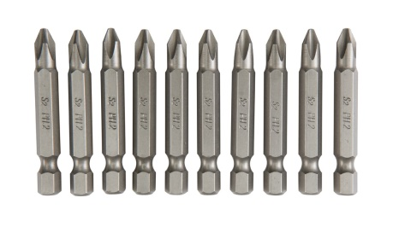 | Ph2 star drill bit 50mm, magnetic
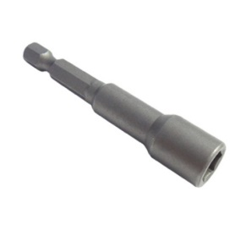 | 5/16”, 8mm ph2 socket bit, magetic  3/8”, 10mm ph2 socket nit magnet
note | 5/16” is 8mm (dia of socket)
 | 3/8” is 10mm (dia of socket)
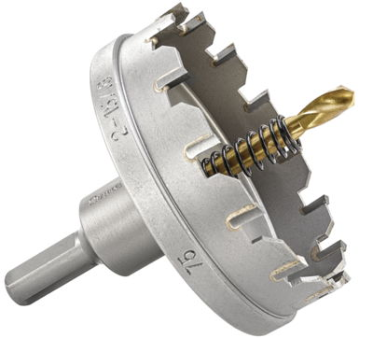 | Carbide tipped hole saw with arbor dia ranging from 20-120mm dia. For cutting on Light guage steel (1-3mm thk)
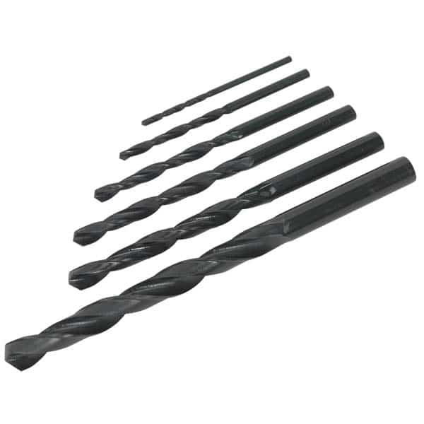 | HSS drill bit for drilling steel (0-3mm)  M16x110mm  M12x110mm
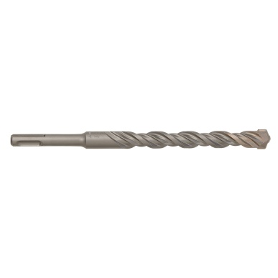 | Concrete drill bit SDS plus shank for drilling concrete surfaces  M12x260mm 0r 210mm  M16x210mm
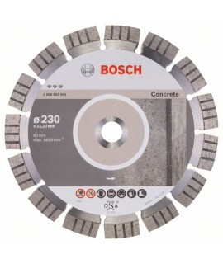 | Diamond cutting disc for concrete surfaces.  4.5” dia  9” dia
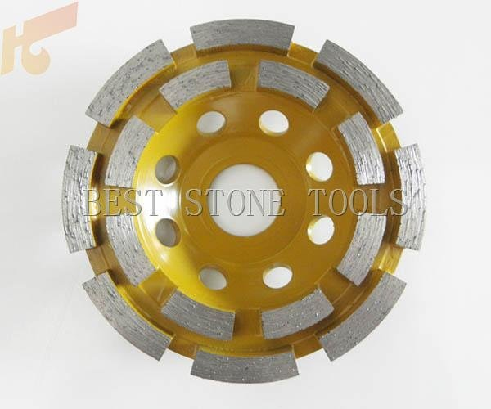 | Cup grinding diamond disc  9” dia or 7” dia
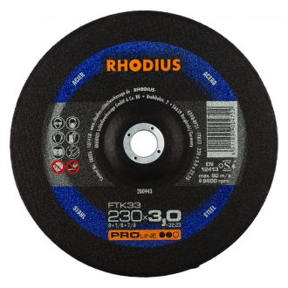 | Grinding disc for steel surfaces  4.5” dia  9” dia

