Republic of Serbia
Аutonomous Province of Vojvodina
Assembly of AP Vojvodina
Office of the President

Vladike Platona bb, 21000 Novi Sad
Т: +381 21 487 41 33
Т: +381 21 487 41 43
Т: +381 21 487 41 06
INTERNATIONAL FORUM FOR CLEAN ENERGY TECHNOLOGIES
F: +381 21 422 759
protokol@skupstinavojvodine.gov.rs
Date: 15th June 2015

H.E. Ms.Christine CHARREL ep. MORO
Ambassador of the Republic of France in Belgrade

Your Exellency,
It gives me a special pleasure and honour to invite you, as the sponsor of the 9th International Forum for Clean Energy Technologies "SERBIAN ENERGY HORIZON 2020", to participate in its formal opening and plenary session on Tuesday 29th September, 2015 at 09.30 in the Great Hall of the Assembly of the Autonomous Province of Vojvodina in Novi Sad.
In cooperation between the University of Novi Sad, the Faculty of Technical Sciences and the Institute for European Affairs (INEA) from Düsseldorf and with the support of the Assembly and the Government of the Autonomous Province of Vojvodina, over the last nine years this event grew into the most significant gathering of the representatives from the countries, companies and scientific institutions of the Southeast Europe in the field of energy security , renewable energy sources, energy efficiency and clean energy technologies. The last-year 8th Forum gathered over 400 participants from 20 European and other foreign countries.
Our practice was to provide addressing of the ambassadors and representatives of the embassies accredited in the Republic of Serbia at the opening plenary session in terms of short presentation with the reference results of their countries in the field of energy security, sustainable development and energy efficiency, and achievements in these areas. Also, we expect your suggestions for participation of companies from your country specialized in projects in this field as well as specialized teams and individuals delegated by your embassy. In this regard, the organizers of the IX Forum will further contact you and coordinate your eventual address and the participation of other representatives.

We are convinced that our gathering this year as well will contribute more intensive exchange of ideas and solutions in the field of energy and further encourage partnerships and open new perspectives of the investment process in Vojvodina, Serbia and the region of Southeast Europe.
In expectation of welcoming you as a guest and looking forward to confirmation of your participation in this event, please accept our deepest regards.

Respectfully,
István Pásztor Tihomir Simic, PhD
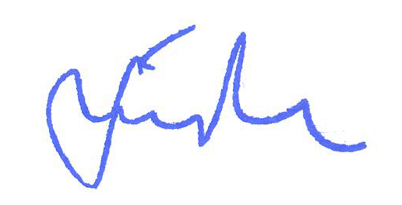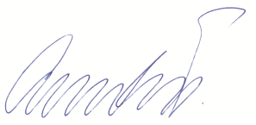
President of the Assembly of AP Vojvodina Chairman of the Forum

