SOUTH AFRICAN

RETAIL FACT SHEET

APPAREL

MARCH 2016

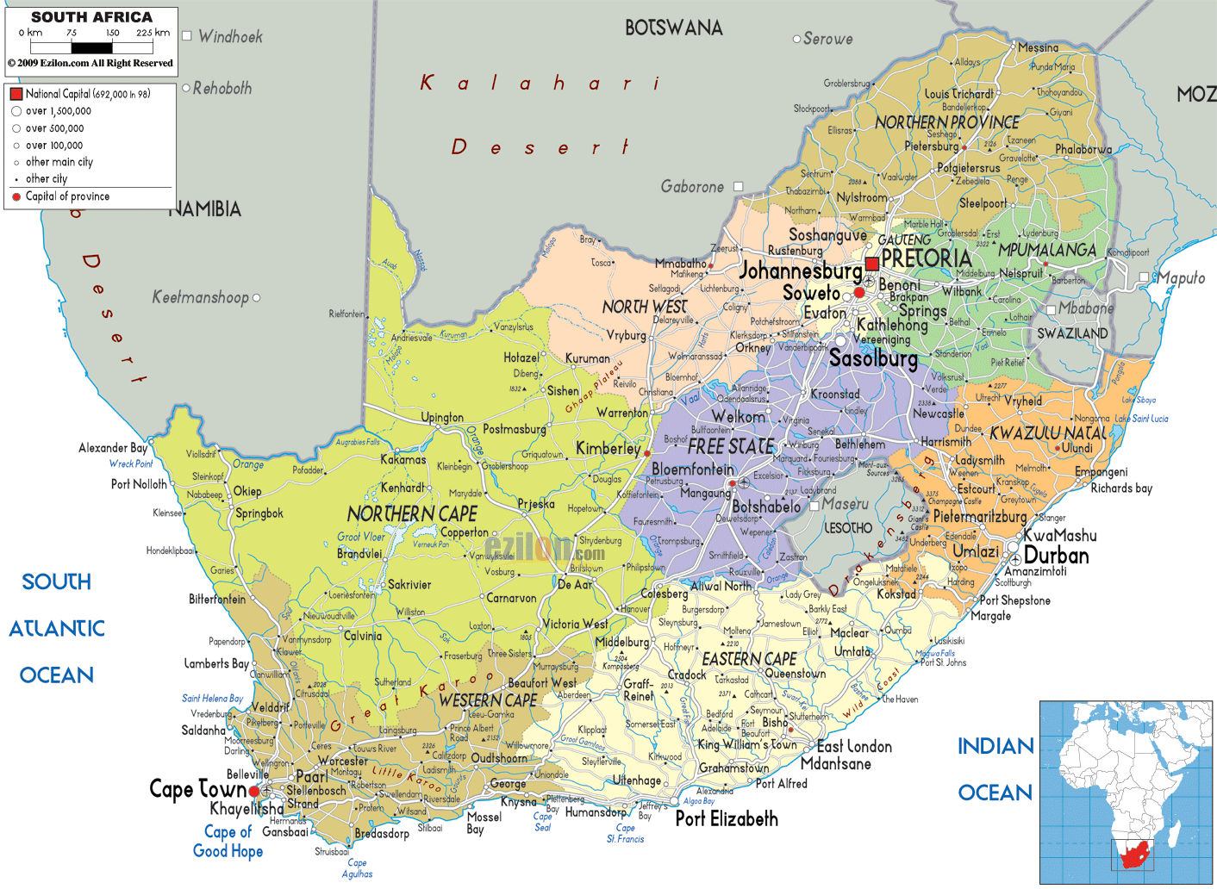



**FLANDERS INVESTMENT & TRADE**

EMBASSY OF BELGIUM

13, FREDMAN DRIVE

FREDMAN TOWERS 8th FLOOR

SANDTON 2196

GAUTENG

REPUBLIC OF SOUTH AFRICA

Phone: +27-11-7834732

Email: [johannesburg@fitagency.com](mailto:johannesburg@fitagency.com)

# EXECUTIVE SUMMARY

This Trade Fact Sheet focuses on the market for **apparel** (clothing, shoes…) in South Africa, and is designed to provide relevant and comprehensive data on the South African retail-side for such products for potential exporters from Flanders to make an informed decision on whether or not to enter the domestic market for these products in South Africa or, alternatively, whether to enhance their existing product offerings in this segment.

Retailers’ performance in 2014 mirrored the country’s economic situation. Macro and socio-economic factors such as the rising cost of utilities and fuel, labor riots, coupled with the falling exchange value of the South African rand contributed to the challenging economic environment. While South Africa remains the most unequal country in the world in terms of income distribution, its middle class continues to expand, driving robust growth in consumption expenditure as consumers flock to the country’s ever-increasing number of shopping malls.

The domestic clothing industry has recently been under intense pressure from cheap Chinese clothing imports resulting in significant job losses. Given the decline in local footwear production and clothing, coupled with local demand for a wide range of styles and colors, these large retailers import a great deal of their requirements direct from a wide range of (domestic, but mainly foreign) suppliers. Whilst China certainly dominates this segment, there’s clearly also a market for high-quality well-designed products from supplier countries such as Flanders, Belgium.

South African households spent an average of 5.3%, or R582, of monthly income on clothing and footwear in 2014, above spending on education at R373, according to the Bureau for Market Research at the University of South Africa. In impoverished shanty towns where the black majority live, the trendiest clothes and latest fashion are common features of township life.

# CONTENTS

**INTRODUCTION**

1. **SOUTH AFRICA – APPAREL – INDUSTRY & TRENDS**
   1. General
2. **CONSUMPTION & DEMAND**
   1. Local Consumption Patterns
   2. Trends in Consumer Spending & Retail
3. **INTERNATIONAL TRADE**

4.1 South African Trade

1. **MAJOR APPAREL RETAILERS**
   1. Background
   2. Importers & Distributors
   3. Impact of Major Retail Groups
   4. South African listed Retailers on the Johannesburg Stock Exchange
   5. Large Apparel Retailers
2. **OPPORTUNITIES & CHALLENGES**
   1. Challenges
   2. Opportunities
3. **INTERNATIONAL ENTRY INTO SOUTH AFRICA**
4. **ADDITIONAL INFO & CONTACT DETAILS**

# INTRODUCTION

South Africa’s economy is the most diversified one on the African continent, and – after Nigeria’s – its largest one. South Africa also is a sophisticated and promising market, offering a combination of well-developed First World economic infrastructure with a vibrant emerging market economy.

It has abundant natural resources, a well-developed banking system, good infrastructure with major capital injections to upgrade this further, a reasonable tax structure, a business culture that is not too dissimilar from that of Flanders, with a time difference of maximally only one hour, a fairly stable political climate, a stock exchange ranked among the top 20 in the world and… it is the gateway to other – mainly Southern – African markets.

According to The Wealth Report 2015 (<http://www.knightfrank.com/wealthreport>), the number of ultra-high net worth individuals in Africa will increase by a staggering 59% by the year 2024. This is higher than previous estimates that put the growth over a 10-year period at 34%. In South Africa, Johannesburg stands out as the most important African city. The Wealth Report 2015 ranks it as the 28th most important city globally for ultra-high net worth individuals whilst Cape Town is ranked 36th.

This Trade Fact Sheet focuses on the market for **apparel** (clothing, shoes…) in South Africa, and is designed to provide relevant and comprehensive data on the South African retail-side for such products for potential exporters from Flanders to make an informed decision on whether or not to enter the domestic market for these products in South Africa or, alternatively, whether to enhance their existing product offerings in this segment.

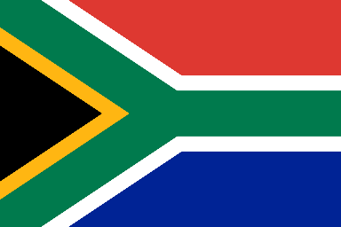

For the purposes of this Fact Sheet, the term “Consumer Goods” is defined as goods that are ultimately consumed rather than used in the production of other goods, and are specifically intended for use in the mass consumer market.

# SOUTH AFRICA - APPAREL INDUSTRY & TRENDS

### **2.1 General**

The South African apparel retail industry had total revenues of $7.4bn in 2014, representing a compound annual growth rate (CAGR) of 8.8% between 2010 and 2014.

The largest proportion for retail sales is through general dealers (some 37%) followed by textiles, footwear and clothing (21%) and food and beverages (9 – 10%).

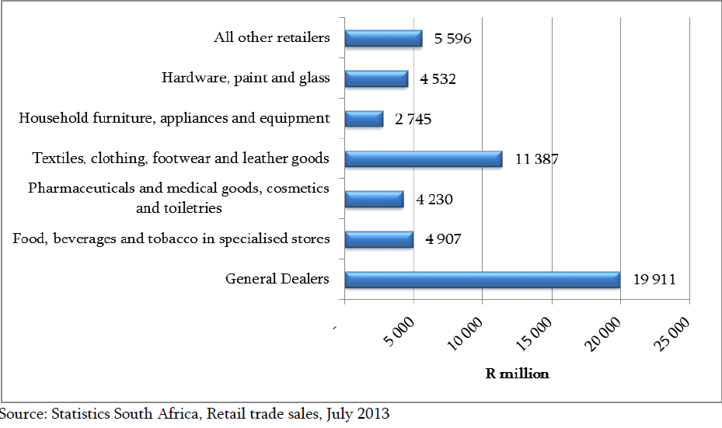

**Retailers’ results mirror economic environment in South Africa**

Retailers’ performance in 2014 mirrored the country’s economic situation. Macro and socio-economic factors such as the rising cost of utilities and fuel, labour riots, coupled with the falling exchange value of the South African rand contributed to the challenging economic environment. As a result of the aforementioned factors, consumer income and spending remained under significant pressure, which weighed heavily on retailers’ performances.

**Internet retailing gains momentum**

Although accounting for only a small share of total retail sales, internet retailing continued to be the most dynamic channel within South Africa’s retailing market at the end of the review period. This can be attributed to improving infrastructure, declining costs, a high rate of mobile penetration and the availability of more payment options. In an effort to align operations with evolving consumer trends, retailers continued to invest in an online presence over the review period. Leading players across various channels within South Africa’s retailing market have adopted multichannel approaches in an effort to supplement bricks and mortar sales with online stores. The growing number of internet retailers specializing in various fast-moving consumer goods indicates the growing significance of this channel.

# CONSUMPTION & DEMAND

### **3.1 Local Consumption Patterns**

While South Africa remains the most unequal country in the world in terms of income distribution, its middle class continues to expand, driving robust growth in consumption expenditure as consumers flock to the country’s ever-increasing number of shopping malls.

Statistics South Africa conducts an Income and Expenditure Survey (IES) every 5 years to establish what South Africans spend their money on, so that the basket of goods which makes up the Consumer Price Index (CPI), used to calculate the inflation rate, can be updated. The last IES was conducted between September 2010 and August 2011.

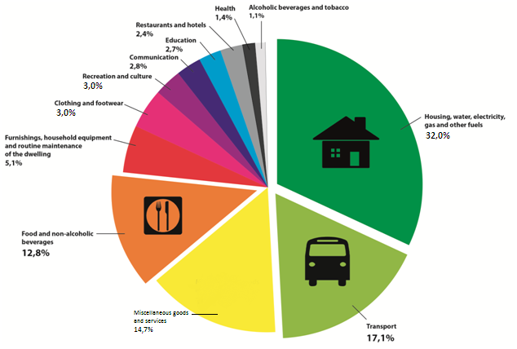

Over the survey period (Sept 2010 – Aug 2011), 32.0% of overall household consumption expenditure went to housing, water, electricity, gas and other fuels. An average household would have spent approximately R 30 505 on this item during the survey year. Black African-headed households spent approximately a quarter (26.5%) and colored-headed households spent three-tenths (30.4%) of their consumption expenditure on this group. Indian/Asian (36.9%) and white-headed (37.9%) households spent more than a third of their expenditure on housing, water, electricity, gas and other fuels.

When combined with expenditure on food and non-alcoholic beverages, which is the fourth-largest expenditure group at 12.8%, these two items account for almost 50% of household expenditure. Essentially, one out of every two Rand spent by South African households goes towards housing and food expenditure items.

**3.2 Trends in consumer spending & retail**

Consumer Spending in South Africa increased to 1,843,463 ZAR Million in the fourth quarter of 2014 from 1,836,090 ZAR Million in the third quarter of 2014. Consumer Spending in South Africa averaged 869,794.17 ZAR Million from 1960 until 2014, reaching an all-time high of 1,843,463 ZAR Million in the fourth quarter of 2014 and a record low of 260,612 ZAR Million in the first quarter of 1960.

* Consumer Spending in South Africa is reported by the South African Reserve Bank.

Retail Sales in South Africa increased 4.20 percent in February of 2015 over the same month in the previous year. Retail Sales YoY in South Africa averaged 4.98 percent from 2004 until 2015, reaching an all-time high of 15.40 percent in September of 2006 and a record low of -6.80 percent in April of 2009. Retail Sales YoY in South Africa is reported by the Statistics South Africa.

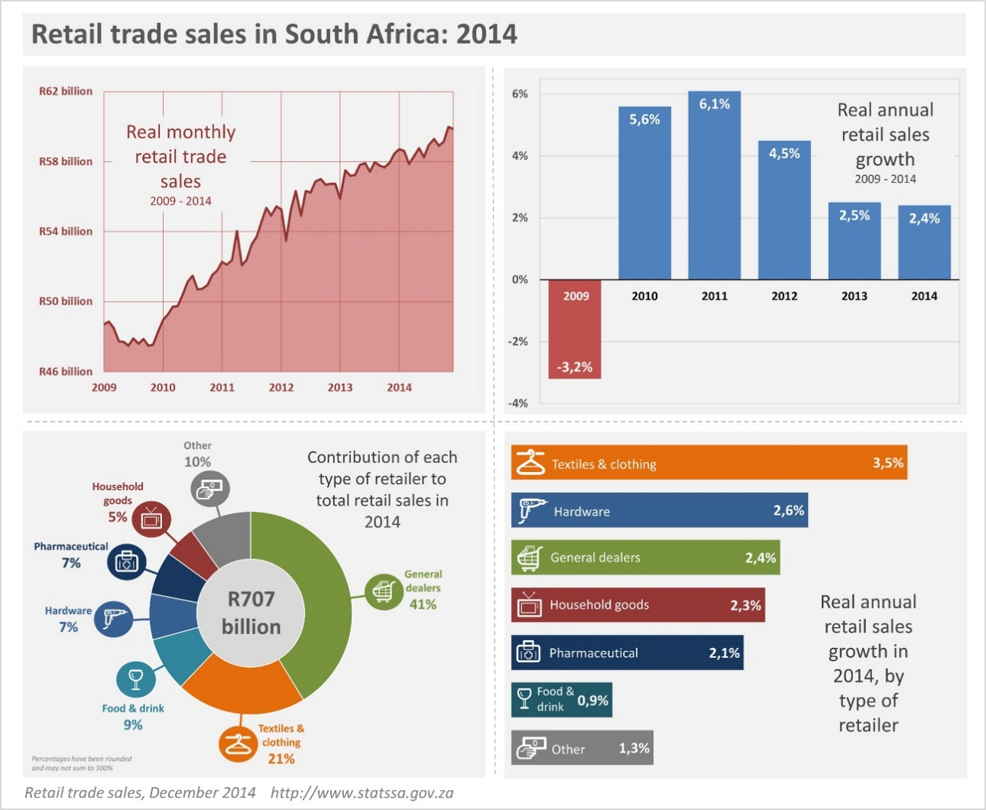

Also visit:

* <http://beta2.statssa.gov.za/publications/P62421/P62421May2014.pdf>
* <http://www.tradingeconomics.com/south-africa/consumer-spending>

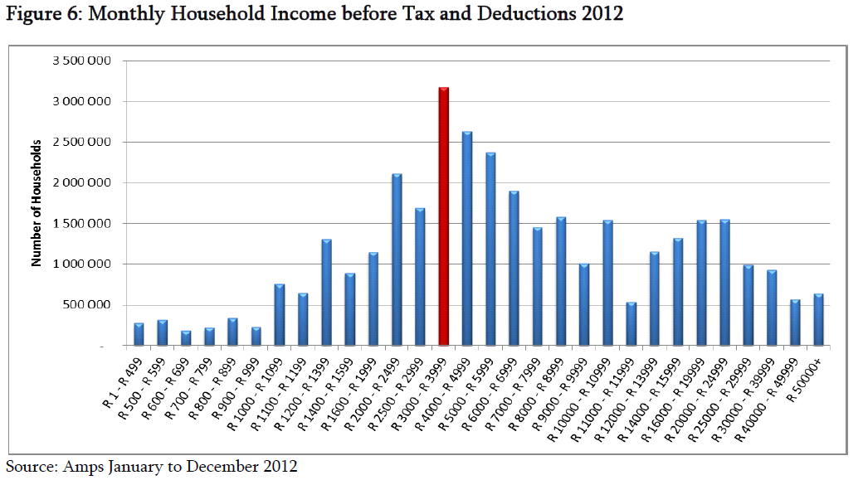

**Example of Consumer Clothing Trends:**

*Consumers like to choose from a wide variety of styles and are turning increasingly to natural fabrics*

The South African textile and clothing market is characterized by a strong demand for variety. However, this has not been matched by a rise in the volume of domestic consumption which has remained low by international standards. In other words, South African consumers like to choose from a wide variety of colors, styles and fabrics but purchase small volumes of any one type of product. This is the challenge facing retailers and one of the main reasons why order volumes are fairly low. Consumers are also moving toward more natural fabrics and fibres. Woolworths is leading the way and the company has introduced a Green Label as part of its Good Business Journey. Under the Journey the company is accelerating efforts to reduce the environmental impact of its products and of the processes used in making them by introducing items made with sustainable fibres such as organic cotton, eco-wool, bamboo, hemp and soya. Woolworths increased total sales of clothing made from organic fibres to more than R 1 billion at the end of 2012.



# INTERNATIONAL TRADE

The domestic clothing industry has recently been under intense pressure from cheap Chinese clothing imports resulting in significant job losses. China is currently under severe wage cost pressure with wages having increased by between 30 and 50 % over the past three years. As Gauteng is the most densely populated province in South Africa we are labor abundant and establishing a clothing manufacturing base in Gauteng is a very real possibility. South Africa hopes investors will look at it as home of their investments.

* 1. **SOUTH AFRICAN TRADE**

**FIGURE 2.1.1 South Africa textiles, clothing and leather goods trade with the world (R) bn.**

**Source: HIS Global Insight 2014**

The graph above shows that between 2008 and 2013 the value of exports has always been lower than that of imports.The global economic crisis seems to have had an impact on both exports and imports which both declined in 2009, and since then imports have been increasing. The year 2013 and the other previous years have recorded a significant volume of imports which led to a trade deficit. This scenario signifies the need of more textile, clothing and leather goods to satisfy high level of demand. South African government has started introducing more ways to assist the sector, the industry has improved which is reflected by the double increase in export figures.

**TABLE 2.1.1 Top 10 Textile exports for 2013**

|  |  |
| --- | --- |
| **Product** | **Value(R)** |
| Other made textile articles, sets, worn clothing etc. | 379994623 |
| Articles of apparel, accessories, not knit or crochet | 185558912 |
| Articles of apparel, accessories, knit or crochet | 177951138 |
| Manmade staple fibres | 85852943 |
| Impregnated, coated or laminated textile fabric | 80759750 |
| Wadding, felt, nonwovens, yarns, twine, cordage, etc. | 55615401 |
| Manmade filaments | 53577203 |
| Carpets and other textile floor coverings | 36941584 |
| Cotton | 19869109 |
| Special woven or tufted fabric, lace, tapestry etc. | 6898851 |

**Source: Quantec 2014**

The export of other made textile articles, sets and worn clothing has been significantly greater than all of the other categories. The major contributors to exports of sales are tents and camping goods, which contributed the majority of total exports in 2013.

**TABLE 2.1.2: Top 10 Textile imports for 2013**

|  |  |
| --- | --- |
| **Product** | **Value(R)** |
| Articles of apparel, accessories, knit or crochet | 2690207805 |
| Articles of apparel, accessories, not knit or crochet | 2463283623 |
| Other made textile articles, sets, worn clothing | 810504229 |
| Wadding, felt, nonwovens, yarns, twine, cordage, etc | 755239884 |
| Manmade filaments | 704503576 |
| Cotton | 650568418 |
| Impregnated, coated or laminated textile fabric | 610221138 |
| Manmade staple fibres | 414745219 |
| Carpets and other textile floor coverings | 258689053 |
| Knitted or crocheted fabric | 240005542 |

**Source: Quantec 2014**

Major categories driving textile imports are (i) Articles of apparel, accessories, knit or crochet (ii) Articles of apparel, accessories, not knit or crochet.

# MAJOR APPAREL RETAILERS

[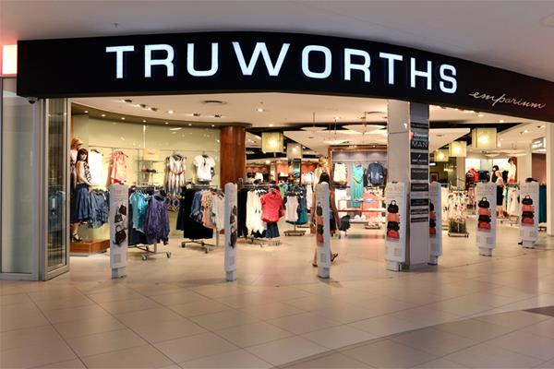](http://www.google.com/url?sa=i&rct=j&q=&esrc=s&source=images&cd=&cad=rja&uact=8&ved=0CAcQjRw&url=http://retailtopnews.com/tag/sa/&ei=QsScVYbXKMmVUaa0m5AL&bvm=bv.96952980,d.ZGU&psig=AFQjCNGY26mxKCjpyS0SziZHVqjLs79GBg&ust=1436423536735954)

* 1. **BACKGROUND**

A particular characteristic of the South African retail sector is that a handful of retail groups operate a large number of brand formats. A visit to any South African shopping mall will show a relative large number of retail brand, though – unnoticed by many – belonging to only a handful of players.

Given the decline in local footwear production and clothing, coupled with local demand for a wide range of styles and colours, these large retailers import a great deal of their requirements direct from a wide range of (domestic, but mainly foreign) suppliers.

Whilst China certainly dominates this segment, there’s clearly also a market for high-quality well-designed products from supplier countries such as Flanders, Belgium.

As mentioned higher, these large retailers often prefer sourcing and negotiating directly with suppliers on large volume items where they like to be in control of both production and delivery cycles. On smaller or niche items, or on truly world-renowned brand items, retailers are happy to deal with local agents.

Many of the large retail groups have a houseware brand (i.e. Edcon has Boardman’s Stores; Foschini has @Home and Mr Price has Price Home etc.).

* 1. **IMPORTERS & DISTRIBUTORS**

Whilst retailers buy a part of their requirements direct from foreign suppliers, they also deal with specialist importers and agents who buy internationally on their behalf. The retailers approach the agents directly for a specific requirement, usually in relation to a new range or line in which they have no experience. It is then up to the agent to bring samples to the retailers and then, on the basis of the feedback, to get the range manufactured and delivered. A handful of agents service the mainstream retail industry. They include Charl Roos, Walt Import & Export, G and T Fashion and Karina M. Mr. Charl Roos is a well-known agent who procures predominantly house brands for the Edcon Group. He looks for fashionable items at a reasonable price targeted at the middle-income market. He works with a number of foreign suppliers. Possible new suppliers would be expected to make a presentation to him of ranges of goods and their pricing. Walt Import & Export is a well-established company that specializes in bulk orders on behalf of various chain stores. It focuses on basic casual and sportswear. Again, a new supplier would be expected to make a detailed presentation to the company. G and T Fashion specialize in women‘s casual wear, swimwear and sportswear at the high end of the market. It deals in both house brands and multi-brands such as Soviet and Guess. Karina M focuses specifically on the discount market, importing primarily from China on the basis of price.

South Africa has a large number of apparel importers and distributors. In some cases, retailers actually prefer dealing with local companies (agents / distributors) because of their knowledge of the local market as well as their familiarity with the retailer’s processes. Most often, goods represented by agents have brand value either internationally or at the very least in their country of origin. Generally, they take on the task of not only negotiating orders with major retailers, but would also take care of other tasks related to getting the product on the shelves – including customs clearance, port and rail charges, documentation, warehousing and financial arrangements.

It are the agents, then, whom are thus responsible for adhering to regulations and control imposed on imported products.

* With some of the retail groups this role will include getting the product delivered to a particular store, or merchandising in-store.

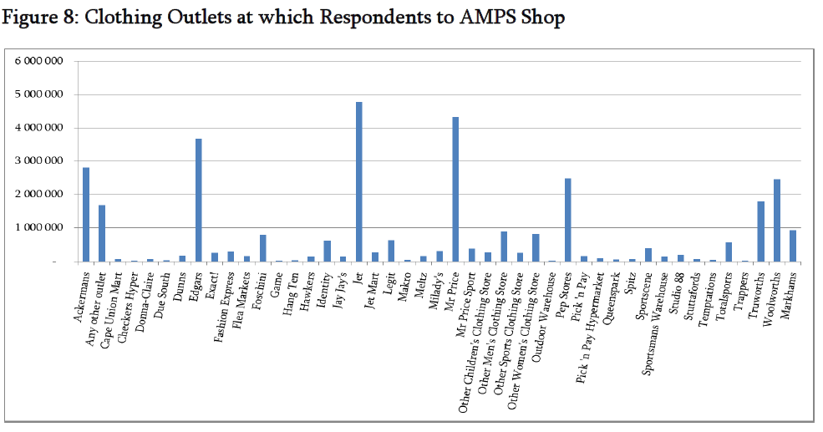

* 1. **IMPACT OF MAJOR RETAIL GROUPS**

Six major retail groups dominate the clothing sector: Edcon, Foschini, Truworths, Pepkor, Woolworths and Mr. Price. These retail groups procure what they can from local manufacturers and import to make up for the shortfall in volumes or in areas where the local industry is either unable to supply or is uncompetitive. Outside the market served by the major groups, there is a smaller, higher-end market for specialty stores. These stores either form part of a group or are independently owned and managed. A good example is the Platinum Group which is a Cape based retailer dealing in leading designer labels (Jenni Button, Hilton Weiner, Urban, Aca Joe and Vertigo). The Group has 57 stores in prime locations in all the premier shopping centers in the country. Another is the Queenspark group, which operates about 40 stores in the country and caters to the needs of the older, more fashionable woman.

Procurement by the independently owned stores is more fragmented and volumes are smaller.

These stores generally serve the higher income groups and often carry major international brands which they purchase through local agents. The supermarkets do not sell clothing in a meaningful way. The exception is Pick ‘n Pay which retails its own label clothing, Fresh Produce, through its stores.

* 1. **SA LISTED RETAILERS (JOHANNESBURG STOCK EXCHANGE / JSE)**

|  |  |  |
| --- | --- | --- |
| **COMPANY** | **MARKET CAPITALISATION (ZAR)** | **OTHER** |
| **Mr. Price** | **49.942.888.276** | *Mr. Price has 1029 corporate owned and 26 franchised stores in Africa. Headquarters in Durban, Kwa Zulu Natal.* |
| **Pick n Pay** | **28.946.945.867** | *Headquarters in Kenilworth, Western Cape* |
| **Truworths** | **30.506.081.071** | *Listed on The JSE & The Namibian Stock Exchange. Headquarters in Cape Town* |
| **Woolworths** | **67.903.402.033** | *Headquarters in Cape Town* |

***Source: Money web, 2014***

**Other Major retailers that are listed on the JSE include:**

* Adidas Pty Ltd
* Pepkor
* Edcon
* Nike Inc.

Apparel specialist retailers continued to dominate from 2012 onwards. This channel faced growing price competition from alternatives such as variety stores, hypermarkets and street markets within other non-grocery retailers. As a result of the economic downturn, many consumers shopped around and opted for the store offering the lowest price. Volume growth rates are expected to drop into the future. This will be linked to South Africa's ongoing economic climate and consumers' concerns over high personal debt levels. However, value growth is expected to be slightly stronger into the future. This may be due to rising production costs in major source countries such as China, although a growing focus on fashion brands as status symbols will also boost constant value sales.

* 1. **LARGE APPAREL RETAILERS**
     1. EDCON

Edcon Pty (LTD) is the largest clothing, footwear and textiles (CFT) retailing group in South Africa. Edcon is estimated to have 31% market share of the CFT retailing group. The company has about 1,228 stores operating in South Africa, Botswana, Namibia, Swaziland and Lesotho. Through its recent acquisitions, Edcon retail business has added top stationery and houseware brands as well as general merchandise to its CFT portfolio. The company also provides credit facilities and financial service products to the Group’s over four million card holders. Edcon’s retail business is structured under two divisions; the Department stores division, which includes Edgars, CNA, Boardman’s, Prato, Red square and Temptations, which serve middle and upper income customers. The second division is the Discount Division, which includes Jet, Jet Mart,

Jet shoes, Legit and Blacksnow, serving lower to middle income customers.

* + 1. WOOLWORTHS HOLDINGS

Image result for woolworths holdings logoWoolworths Holdings Limited is an investment holding company and one of the top 100 companies listed on the Johannesburg Securities Exchange. Its core business focus is the provision of retail and financial services to upper and middle income groups mainly in South Africa but also in Africa, Australia and New Zealand. Woolworths was founded by Max Sonnenberg in 1931 officially opening the doors of the first store in Adderley Street, Cape Town on October 31st. His belief, that success lay in providing customers with superior quality merchandise at reasonable prices, has been instrumental in establishing Woolworths as one of South Africa’s leading retail chains. Today, Woolworths is a South African retail chain that extends, through franchise partnerships, throughout Africa and into the Middle East, trading through more than 400 stores. Woolworths Holdings influence also extends to Australia with a majority share in the Australian apparel retail chain, Country Road.

* + 1. MR PRICE GROUP

Mr Price Group is a fashion value retailer, selling predominantly for cash. Mr. Price Group is one of the fastest growing retailers in South Africa, and operates in the Women's clothing stores sector. Mr Price Group Limited is engaged in the business of retail distribution through 937 stores in Southern Africa and 24 franchised stores in Africa.  The retail chains focus on clothing, footwear, sportswear, sporting goods, accessories and homewares. The Company operates three segments: the Apparel, which retails sportswear, footwear, sporting equipment and accessories; the Home segment, which retails homewares, and the Central Services segment, which provides services to the trading segments, including information technology, internal audit, human resources, real estate and finance. Apparel consists of Mr Price providing Clothing, footwear, accessories and maternity wear; Mr Price Sport providing Sporting apparel, footwear and accessories, and Milady’s offering women's clothing, footwear, intimate wear, cosmetics and accessories. Home consists of Mr Price Home offering Home textiles, homewares, furniture and kids merchandise and Sheet Street offering Bedroom, living room and bathroom ware.

* + 1. TFG (THE FOSCHINI GROUP)

TFG (The Foschini Group) is one of the foremost independent chain-store groups in South Africa. The Group has 17 retail brands that trade in clothing, jewellery, accessories, sporting and outdoor apparel and equipment, cellular goods and services, and homeware to the broad, primarily middle, and upper income groups throughout 2 000+ stores predominantly in Southern Africa. 42.2% of turnover is in the form of cash sales to customers, with the balance being on credit. The majority of merchandise sold in the Group’s stores is under their own brand names. The retail brands include: @home, @home Living Space, Exact, American Swiss, Fabiani, Luella, Sterns, Fashion Express, Markham, Total Sports, Donna Claire, Foschini, Due South, Sport Scene, etc.

* + 1. TRUWORTHS

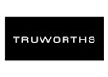Truworths is one of South Africa’s leading fashion retailers and has the following brands in its stable: Truworths, Truworths Man, Identity, YDE and Uzzi. Truworths offers a collection of leisure wear, formal wear, evening wear, lingerie, shoes and accessories designed for the modern fashion-aware woman. Truworths Womenswear offers a wide range of brands. Daniel Hechter exclusive to Truworths, is a European-influenced collection of high quality, modern, timeless designs for men and women. This collection offers a refined feeling of style combined with a French touch, and the sophistication of classic European styling, superior tailoring and luxurious fabrics. Inwear at Truworths offers a cutting-edge range of casual, formal and glamour fashion that demands to be noticed. Truworths Ltd offers an eclectic collection of easy yet sophisticated leisure time dressing for women, men, teenagers, children and toddlers. LTD is a versatile leisure-inspired range that has an urban look with classic undertones. In keeping with this philosophy, LTD captures key international and local trends but always adds a twist. This means placing extra emphasis on color, fabric, design and detail. Innovative and unusual styling makes LTD unique. Truworths also offers a selection of fine quality jewelry, branded watches and sunglasses as well as a superb range of the best international skincare, color cosmetics and fragrance brands for him and her.

* + 1. PEPKOR

Pepkor is a South African based investment holding company with retail interests in Africa (where it trades in eleven countries), Australia and Eastern Europe. The group, established in 1965, manages a portfolio of retail chains focused on the value market and selling predominantly clothing, footwear and textiles. Its main operating subsidiaries are Pep and Ackerman’s in South Africa, Best & Less in Australia and Pepco in Poland. The group trades from more than 3 800 stores and employs close to 32 000 people.

# OPPORTUNITIES & CHALLENGES

* 1. **CHALLENGES**

South Africa’s apparel industry is relatively developed and is one of the country’s top ten sources of employment, but faces material threats to its future survival. First, despite some locally sourced materials, the sector is heavily reliant on imported materials. Second, the textile industry has been hard hit by Chinese imports in particular, which now have about 70% of the market (about 90% of the apparel sold in the country is now imported).

Third, the US initiated African Growth and Opportunity Act, which cuts tariffs on imports from select African countries, including South Africa, faced an uncertain outlook for South Africa during 2015 due to the uncertain political transition of the US, and dithering on the part of the South African Government. In February 2016 is has been renewed.

In response to these issues, the sector concluded a landmark deal with the Southern African Clothing and Textile Workers Union (SACTWU) in late 2011, to offer 30% lower wages to new employees, as part of a bid to create more jobs.

Amidst such disputes, a significant proportion of production continues to shift to neighboring countries Swaziland and Lesotho, where wage costs are considerably lower and unions are less entrenched.

* Access to finance makes it difficult for smaller businesses to grow and expand their operations.
* Textile mills are particularly vulnerable to the Chinese incursion.
* Robust trade in second-hand clothing from wealthier countries, cloth-makers now face significantly more competition from their Chinese and Indian counterparts.
* The majority of the machinery used in South African textiles, clothing and footwear manufacturing is over 10 years old.
* Growing wage demands and traditional markets not growing.
  1. **OPPORTUNITIES**

Retail sales in South Africa increased 4.1 percent year-on-year in December of 2015, compared to a downwardly revised 3.8 percent rise in the previous month and above market expectations. The highest growth rates were recorded for household furniture, appliances and equipment (+7.7 percent), textiles, clothing, footwear and leather goods (+5.8 percent) and general dealers (+4.6 percent). For the full 2015, sales went up by 3.3 percent, boosted by general dealers and retailers in textiles, clothing, footwear and leather goods. On a monthly basis, retail sales fell 0.9 percent. Retail Sales YoY in South Africa averaged 4.97 percent from 2003 until 2015, reaching an all-time high of 15.50 percent in September of 2006 and a record low of -6.20 percent in April of 2009. Retail Sales YoY in South Africa is reported by the Statistics South Africa.

In the last year at least a half-dozen foreign clothing brands, including Super dry, Steve Madden and G-Star, have opened outlets in [South Africa](http://topics.bloomberg.com/south-africa/). While there is no shortage of retailers in South Africa, the average person has not had access to these international brands: hence, there is growth.

South African shoppers have been able to buy brands such as Gap and Levi locally for some years, though mostly in other companies’ stores and typically at prices that were 30% to 50% higher than in their home markets. For many [South Africans](http://topics.bloomberg.com/south-africans/), having foreign brands in their closet meant they had money to travel and buy abroad. International clothing brands classifies an individual as being wealthy.

**NICHE MARKET FOR FLEMISH EXPORTERS TO EXPLORE**

* South Africa has a market for large size clothingthat companies in Asia generally do not have the capacity to supply. A clothingcompany with the ability to service this market segment could find good opportunities.
* It has also a market for companies that are able to work with small minimum orders. Asian companies often work with minimum order sizes that are far larger than the volumes small and medium sized operators in South Africa are able to place.
* The market for green fabrics is growing strongly. Companies producing garments from organic cotton or bamboo fiber would find good opportunities in South Africa.
* In addition, there are the markets for special goods which the South African clothing industry does not have the capacity to produce. These include items like padded jackets, casual woven tops and bottoms with embellishment, generally anything that requires sophisticated washing and finishing. All these products are imported.
* The market for baby wear and children’s wear, for which there is limited local manufacturing capacity, is also ripe for the picking.

# INTERNATIONAL ENTRY INTO SOUTH AFRICA

Approaching the South African market can sometimes be difficult. South African retailers, importers and agents tend to buy from tried and trusted sources, making entry into the market a challenge for new suppliers. A direct approach to retailers is often the most effective way of capturing their attention. It would be wise for companies with strong design abilities to target retailers in their marketing campaigns as a way of making their companies known.

Retailers are the primary drivers in the South African clothing industry, dictating the fortunes of local manufacturers and determining the annual level of imports. According to Stats SA, total retail sales of textiles, clothing, footwear and leather goods amounted to R 99.7 billion (US$ 11.8 billion).

Retailers employ a mixed pattern of buying. They buy part of their requirements direct from suppliers abroad. They also deal with agents of foreign suppliers who are based either in South Africa or in the supplying countries themselves. In all cases, the product needs to be consigned direct to the stores, labelled and packaged ready for display.

The South African retail sector follows the European market very closely and buyers will look first and foremost at the fashion ability of the product lines proposed by new suppliers before asking questions on volumes, delivery and price. Samples or photographs presented to retailers therefore always need to be in the latest styles.

South Africa‘s International Apparel, Textile, Footwear and Machinery Fair, held annually in Cape Town, offers a platform for reaching retailers. All the large buyers and agents come to the fair. A number of countries choose to set up country pavilions at this fair. Such pavilions work well as they not only market specific companies but the capabilities of the individual country as a whole.

Among the continent’s most brand conscious consumers, South African households spent an average of 5.3%, or R582, of monthly income on clothing and footwear in 2014, above spending on education at R373, according to the Bureau for Market Research at the University of South Africa.

In impoverished shanty towns where the black majority live, the trendiest clothes and latest fashion are common features of township life.

South Africa is a party to several trade regimes under which certain clothing imports enter the country at preferential duty rates. The European Union/South Africa Free Trade Agreement came into effect in January 2000. Under the terms of the agreement, the European Union reduced its import tariffs to zero over a period of seven years. South Africa undertook to reduce its duties to 50% of the MFN (most favored nation) tariff level over an eight-year period. Today, with some exceptions on which no duties are imposed, imports from EU attract a preferential tariff of 20%.

# ADDITIONAL INFO & CONTACT DETAILS

### Where to turn for more information?

**Please forward your specific requests for more detailed information on importers, distributors, agents, retailers & buyers to the FIT-office located nearest to you.**

