Press Release
Brussels, April 9, 2018
Flanders Investment & Trade
Flemish merchandise exports hit new record in 2017
Trade in goods exports by Flemish companies amounted to EUR 317 billion in 2017, which was a 5% increase compared with 2016, thus reaching a new all-time high. This analysis, compiled by Flanders Investment & Trade, is based on the annual trade figures published by the National Accounts Institute at the National Bank of Belgium.

The 5% increase in Flemish exports in 2017 marked the 8th consecutive year of export trade growth and was the third largest such rise since the global economic crisis of 2008 - 2009. At a 5% increase, Flemish exports altogether fared slightly worse than overall annual export trade from the EU which in 2017 grew at a faster pace (+7,53%).
Flanders accounted for 83.22% of the total value of exports from Belgium, with the Walloon region taking a 14.24% share and the proportion held by Brussels standing at 2.55%.
Traditionally, EU countries rank among the prime export partner countries for Flanders, its neighbouring countries in particular. In 2017, things were no different as intra-EU exports experienced a 4.7% increase compared with 2016. Yet, far stronger export growth was achieved to African markets (+13%) and to non-EU European partner countries in Greater Europe (+17.6%).
Chemicals and pharmaceutical products remained last year’s top export commodities, accounting for upward of 1/5 of the total value of Flemish merchandise exports.
Exports to EU countries: substantial as ever and rising slowly

About 70% of all 2017 exports from Flanders was destined for markets within the European Union. EU-bound deliveries rose by 4.7% compared with 2016. The bulk of Flanders exports is dispatched to neighbouring markets, with more than half of its exports —51,64% — going to Germany, the Netherlands, France, the United Kingdom and Luxembourg.
Germany remained the largest export partner in 2017, cornering a 16.79% share of total exports, which represented a 4.5% increase on 2016. The Netherlands overtook France as runner-up among top Flemish export markets: 2017 exports to the Netherlands went up 13.72%. The country thus experienced the largest increase of export value of all Flemish markets. As an export market, France dropped to third place from second, following a mere 0.38% increase in year-on-year exports in 2017.
In its intra-EU28 export trade, Flanders exports declined in just 2 markets: sales to Italy dropped by 1.2% and export trade with the United Kingdom also fell slightly (minus 0.4%).
It seems that so far the main impact on trade with Britain following the Brexit vote back in June of 2016 seems to be the relative currency volatility of the pound. Looking at the 2017 trade figures with the UK, the drop in the value of the pound does not seem to have resulted in a major downturn of Flemish exports (-0,4%).

Exports to non-EU European markets on the up

Exports from Flanders to non-EU European countries in Greater Europe amounted to 17,45 billion euro, a 17.6% increase on 2016. Among the markets recording considerable value increases were Switzerland (+22.2%), Turkey (+18.9%) and Russia (+11%).
Export growth across non-European markets: ranging from sturdy in Africa to reasonable in Asia

At 13%, export growth to Africa proved particularly hefty in 2017. Sub-Saharan Africa trended upwards even more strongly (+15.6%), with 2017 export sales to Nigeria recording a 32.6% hike.
Across Asia, export results also improved slightly (+3.7% on 2016), most notably in China, our second Asian market (+15.6%,), as well as in Vietnam (+22.6%), the Philippines (+18.3%), Thailand (+14.5%) and South Korea (+7%).
2017 exports to Middle-Eastern markets rose by 4.6%, with performances particularly glowing in the United Arab Emirates (+4.1%), Saudi Arabia (+4.8%), Iran (+22.2%) and Qatar (+23%).
Finally, Flemish exports down under grew by 4.2%: both Australia and New-Zealand experienced export value increases of 3.47% and 12.7% respectively.
Exports to United States take a beating in 2017
Only on the American continent did Flemish exports contract in 2017, a 4.56% decline, due to a large extent to the poor showing of annual sales to the United States, plummeting by as much as 13.9%.
Commodities particularly affected by the drop in exports to the US were organic chemicals, down
EUR 1.5 billion (or minus 44%) and pharmaceuticals, down over EUR 1 billion (-21.7%).
Conversely, Canada posted far better figures in 2017, as Flemish exports there surged by 23.2%.
Latin-American markets also yielded positive 2017 results, with Brazil — our 18th market — even ranking fifth in terms of export value increase during that year and Flemish exports to Brazil soaring by an impressive 40.44%.
Exports by commodity

In 2017, combined annual exports of chemicals and pharmaceuticals stood at EUR 68.6 billion and remained the top export commodity group, with a 21.6% proportion of total Flemish exports.
Transport materials, ranking second among export commodities sold, saw a 7.4% value increase and accounted for 13.1% of total merchandise exports in 2017.

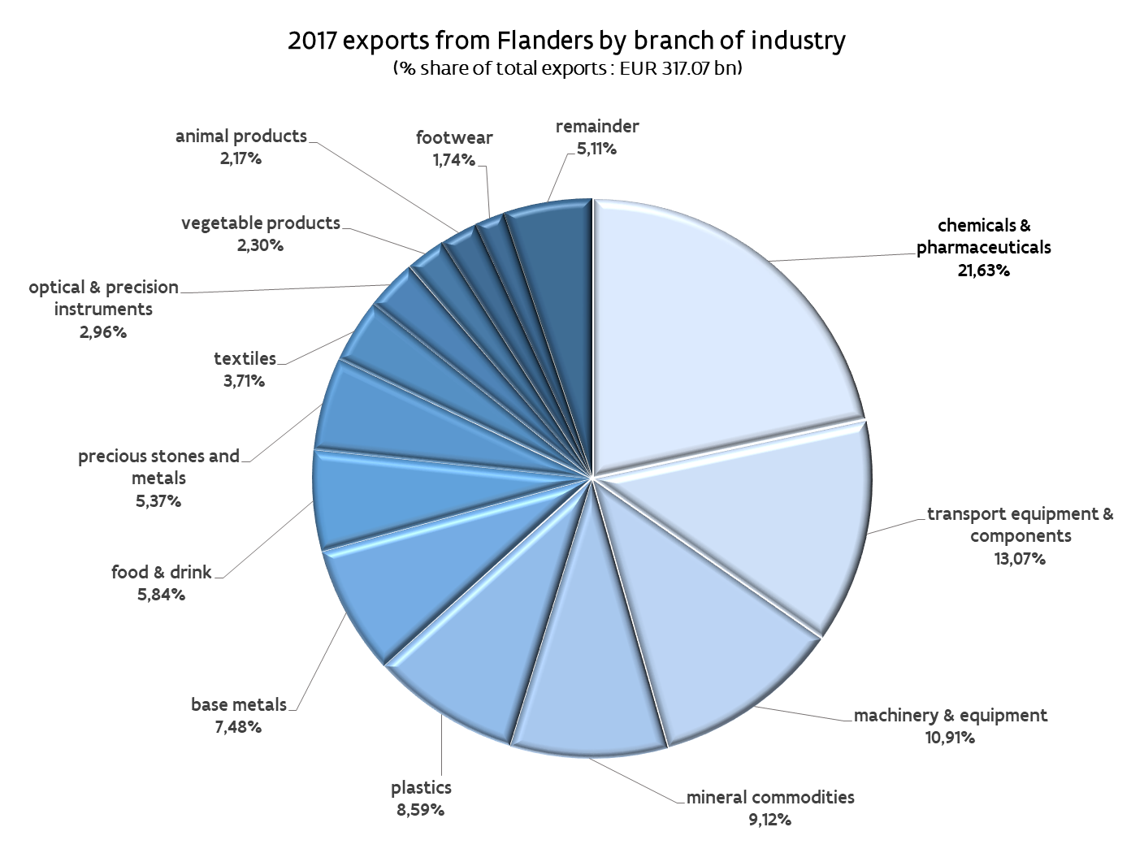

Fired up by increased export volumes and oil price hikes alike, mineral products experienced the largest annual value increase of 2017, up EUR 6.25 billion on 2016 (+27.6%).
With exports totalling EUR 27.23 billion and up 8.9% on 2016, plastics, our fifth export commodity by value, also ranked among the high-growth industries in 2017. The same went for the third-ranking export line, machines, mechanical appliances and electronic equipment, with 2017 sales up 4.2%.

Supporting and promoting international business development… an ongoing concern

“Soaring exports from Flanders definitely represent a boon to the economy”, says Mrs. Claire Tillekaerts, CEO at Flanders Investment and Trade (FIT). Taking their business abroad is of paramount importance for companies in their bid to both maintain and strengthen their competitiveness on the global market.
Last year, as part of our core mission to support Flanders-based exporters, FIT organized 124 business trips, set up group pavilions at international trade shows and staged seminars, while also scheduling no less than 4 336 B-to-B matchmaking sessions between Flemish entrepreneurs and their foreign counterparts.
Furthermore, a total of 355 trade leads and 83 market reports were generated, 4 149 Flemish companies were given export guidance, while another 2 134 of them were granted financial assistance in order to boost their export efforts.

Flanders foreign trade: a closer look
As with its exports, total merchandise imports into Flanders also reached a new high in 2017, when imports of foreign goods amounted to EUR 299 billion, which was a 3.12% increase compared with the 2016 value.
Further information:
- Flemish foreign trade – Key points
- Flemish foreign trade – In-depth analysis
- Infographics

