Flanders foreign trade in 2017: summary
- Merchandise exports by Flemish companies amounted to over EUR 317 billion in 2017, which was a 5% increase compared with 2016.
- Throughout 2017, quarterly trade figures had consistently indicated that Flemish annual exports would end up reaching a new high.
- At 5%, the value increase of 2017 exports by Flanders was significantly higher than the growth rate in 2016 (+1.33%). 2017 marked the 8th consecutive year of export trade growth and was the third largest such rise since the global economic crisis of 2008 – 2009.
- Overall, the 5% value gain in 2017 exports may seem a pretty robust increase, but less impressive when compared with the all-EU export performance. According to recent trade figures issued by Eurostat, average growth of EU exports as a whole amounted to 7.53% in 2017, an increase led in particular by the Netherlands (+11.8%) and Poland (+11.7%) and Spain (+8.27%)
Provisional data on global merchandise trade from the World Trade Organisation even estimate annual export trade growth in 2017 at a hefty 10%, double the percentage rise in annual foreign sales from Flanders.
- Flanders accounted for 83.22% of the total value of annual exports from Belgium, with the Walloon region taking a 14.24% share and the proportion held by Brussels standing at 2.55%.

- About 70% of all 2017 exports from Flanders was destined for markets within the European Union.
EU-bound deliveries rose by 4.7% compared with 2016. The bulk of Flanders exports was dispatched to neighbouring markets, with more than half of its exports —51,64% — going to Germany, the Netherlands, France, the United Kingdom and Luxembourg.
  - Germany remained the largest export partner in 2017, cornering a 16.79% share of total exports, which represented a 4.5% increase on 2016. As an export market, France dropped to third place from second, following a mere 0.38% increase in year-on-year exports in 2017.
  - The Netherlands overtook France as runner-up among top Flemish export markets: 2017 exports to the Netherlands went up 13.72%. The country thus experienced the largest annual increase of export value of all Flemish markets.
  - Of all its major EU trade partners, Flanders intra-community exports declined in just 2 markets: sales to Italy dropped by a mere 1.2% and export trade with the United Kingdom also fell slightly (-0.4%).
It seems that so far the main impact on trade with Britain, following the Brexit vote back in June of 2016 seems to be the relative currency volatility of the pound. Looking at the 2017 trade figures with the UK, however, the drop in the value of the pound does not seem to have resulted in a major downturn of Flemish exports (-0.4%).

- As with exports, total merchandise imports into Flanders also reached a new high in 2017, when imports of foreign goods amounted to EUR 299 billion, which was a 3.12% increase compared with the 2016 value.

- Non-EU exports from Flanders recorded slightly above-average growth in 2017 (+5.6% against +4.99%).

  - Exports from Flanders to non-EU European countries (Greater Europe) amounted to 17,45 billion euro, a EUR 2.6 billion increase (+17.6%) on 2016. Among the markets recording considerable value increases were Switzerland (+22.2%), Turkey (+18.9%) and Russia (+11%).
  - Across Asia, export results also improved slightly (+3.7% on 2016), most notably in China, our second Asian market (+15.6%,), as well as in South Korea (+7%), Thailand (+14.5%), Taiwan (+12.51%), Vietnam (+22.6%), Pakistan (+25.75%) and the Philippines (+18.3%). In a number of other Asian countries, however, notable export declines appeared, as was the case in India (-1.59%;), our 8th worldwide and highest-ranking Asian market, Japan (-8.69% and 19th worldwide customer to Flanders), Hongkong (-2.53%) and Singapore
(-14.26%).
  - 2017 exports to Middle Eastern markets rose 4.6%, slightly below average, yet with performances particularly glowing in the United Arab Emirates (+4.1%), Saudi Arabia (+4.8%), Iran (+22.2%) and Qatar (+23%).
  - At 13%, export growth to Africa proved decidedly solid in 2017. Sub-Saharan Africa trended upwards even more strongly (+15.6%), with 2017 export sales to Nigeria even recording a 32.6% hike.
  - Finally, Flemish exports down under grew by 4.2%: both Australia and New-Zealand experienced export value increases of 3.47% and 12.7% respectively.
  - Only on the American continent did Flemish exports contract in 2017, a 4.56% decline, mainly due to the poor showing of sales to the United States, where exports took a beating and plummeted by as much as 13.9%, a value decrease of EUR 2.46 billion compared with 2016.
Commodities particularly affected by the drop in exports to the US were organic chemicals, down
EUR 1.5 billion (-44%) and pharmaceuticals, down over EUR 1 billion (-21.7%).
Conversely, Canada posted far better figures in 2017, as Flemish exports there surged by 23.2%, an increase led by chemicals and pharmaceutical products.
Flemish exports in 2017
Continent | 2016 | 2017 | % change  2016 - 2017 | % share 2016 | % share 2017
 | x EUR billion |  | % | % | %
intra-EU28 | 212.24 | 222.25 | +4.72% | 70.28% | 70.09%
extra-EU28 | 89.76 | 94.82 | +5.64% | 29.72% | 29.91%
Europe | 227.07 | 239.69 | +5.56% | 75.19% | 75.60%
European Union (EU28) | 212.24 | 222.25 | +4.72% | 70.28% | 70.09%
Greater Europe  (Europe non-EU28) | 14.83 | 17.45 | +17.61% | 4.91% | 5.50%
Asia | 35.69 | 37.02 | +3.72% | 11.82% | 11.67%
Asia (Central, Eastern, South-Eastern, Southern | 26.50 | 27.41 | +3.43% | 8.78% | 8.65%
Middle East | 9.18 | 9.60 | +4.57% | 3.04% | 3.03%
America | 24.89 | 23.75 | -4.56% | 8.24% | 7.49%
Northern America | 19.52 | 17.47 | -10.47% | 6.46% | 5.51%
Central America | 1.61 | 1.55 | -3.28% | 0.53% | 0.49%
South America | 3.76 | 4.73 | +25.58% | 1.25% | 1.49%
Africa | 10.59 | 11.97 | +12.99% | 3.51% | 3.77%
Northern Africa | 3.17 | 3.39 | +6.82% | 1.05% | 1.07%
Sub-Saharan Africa | 7.42 | 8.58 | +15.62% | 2.46% | 2.71%
Oceania | 1.78 | 1.85 | +4.24% | 0.59% | 0.58%
Australia and New-Zealand | 1.73 | 1.81 | +4.47% | 0.57% | 0.57%
Special & miscellaneaous trade flows | 1.98 | 2.79 | +40.80% | 0.66% | 0.88%
WORLD | 302 | 317 | +4.99% | 100% | 100%

- 2017 brought no major shifts in the order of the top 10 export commodities, ranked by value.
        - In 2017, combined annual exports of chemicals and pharmaceuticals experienced the largest decrease of all traded lines compared with 2016 — down a sizeable EUR 2.9 billion (-4.08%).
With exports totalling EUR 68.6 billion, the twin sectors ranked first as an export commodity group in 2017, holding a 21.6% proportion of total Flemish exports.
        - With EUR 41.4 billion worth of annual exports, the motor vehicles / transport materials branch took second place accounting for a 13.1% share of total Flemish exports, following a sound 7.4% rise in 2017.
        - Fired up throughout 2017 by increased export volumes and petroleum price hikes alike, mineral products posted the highest export growth figures of the year, with annual sales skyrocketing by EUR 6.3 billion, up 27.6% year-on-year.
Accounting for no less than 94% of the mineral products commodity group, mineral fuels — Flanders’ second most important export commodity in 2017 — recorded a value increase of just under EUR 6 billion (+28.3%), following 3 consecutive years of declining export values in 2014 (-9.9%), 2015 (-28.3%) and
2016 (-14.2%).
        - With exports totalling EUR 27.23 billion and up 8.9% on 2016, plastics, our fifth export commodity by value, also ranked among the high-growth industries in 2017.
        - Machines, mechanical appliances and electronic equipment, our third most important export line with a 10.9% proportion of total annual exports, also enjoyed robust export growth in 2017 (+4.2%).

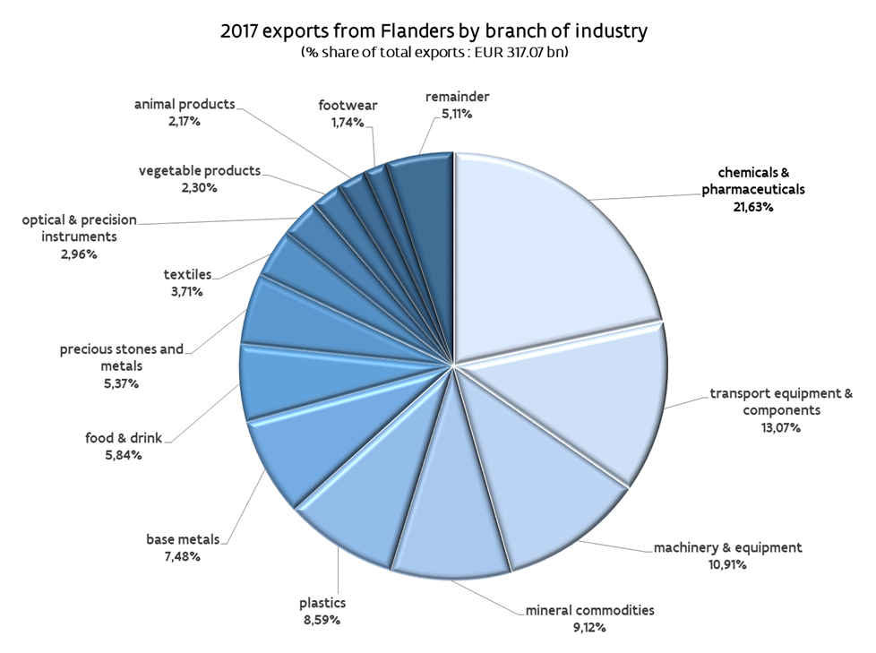

- Flemish 2017 merchandise imports were worth EUR 299 billion, up 3.1% or equivalent to a EUR 9.06 billion value increase compared to 2016.
- in 2017, the Holland - mineral fuels country and commodity combination once again proved instrumental in the risen value of Flanders worldwide imports. The Netherlands single-handedly accounted for over half of the total value increase of imports and thus confirmed its role as prime import provider (+9.71%) of 17.92% of overall Flemish imports in 2017.
2017 Imports from Germany, runner-up as a supplier to Flanders, were down 6.08% (11.78% share of total imports), with France traditionally trailing third, up 5.05% on 2016 and taking a 8.17% share of total imports.

- in 2017, the mineral products commodity group experienced the second largest increase in import value (EUR +45.2 billion or up 24.13%, with fuels featuring as star commodity. Ranked second among all import supplies, mineral products took up about 15% of all Flemish imports.
Despite a 2.66% drop in their combined import value, chemicals and pharmaceuticals firmly held on to their top spot as import commodities, accounting for 19.72% of total trade in goods imports in 2017.
- Transport equipment saw the value of its imports decrease by 11.64%, leading it to snatch up a 13.1% share in total imports (but for cars, other road vehicles and automotive components, imports only slid by 6.83%).
Some of the other key branches did, however, record some import value growth, as was the case for machinery (+5.57%), base metals (+17.06%) and plastics (+12.6%).
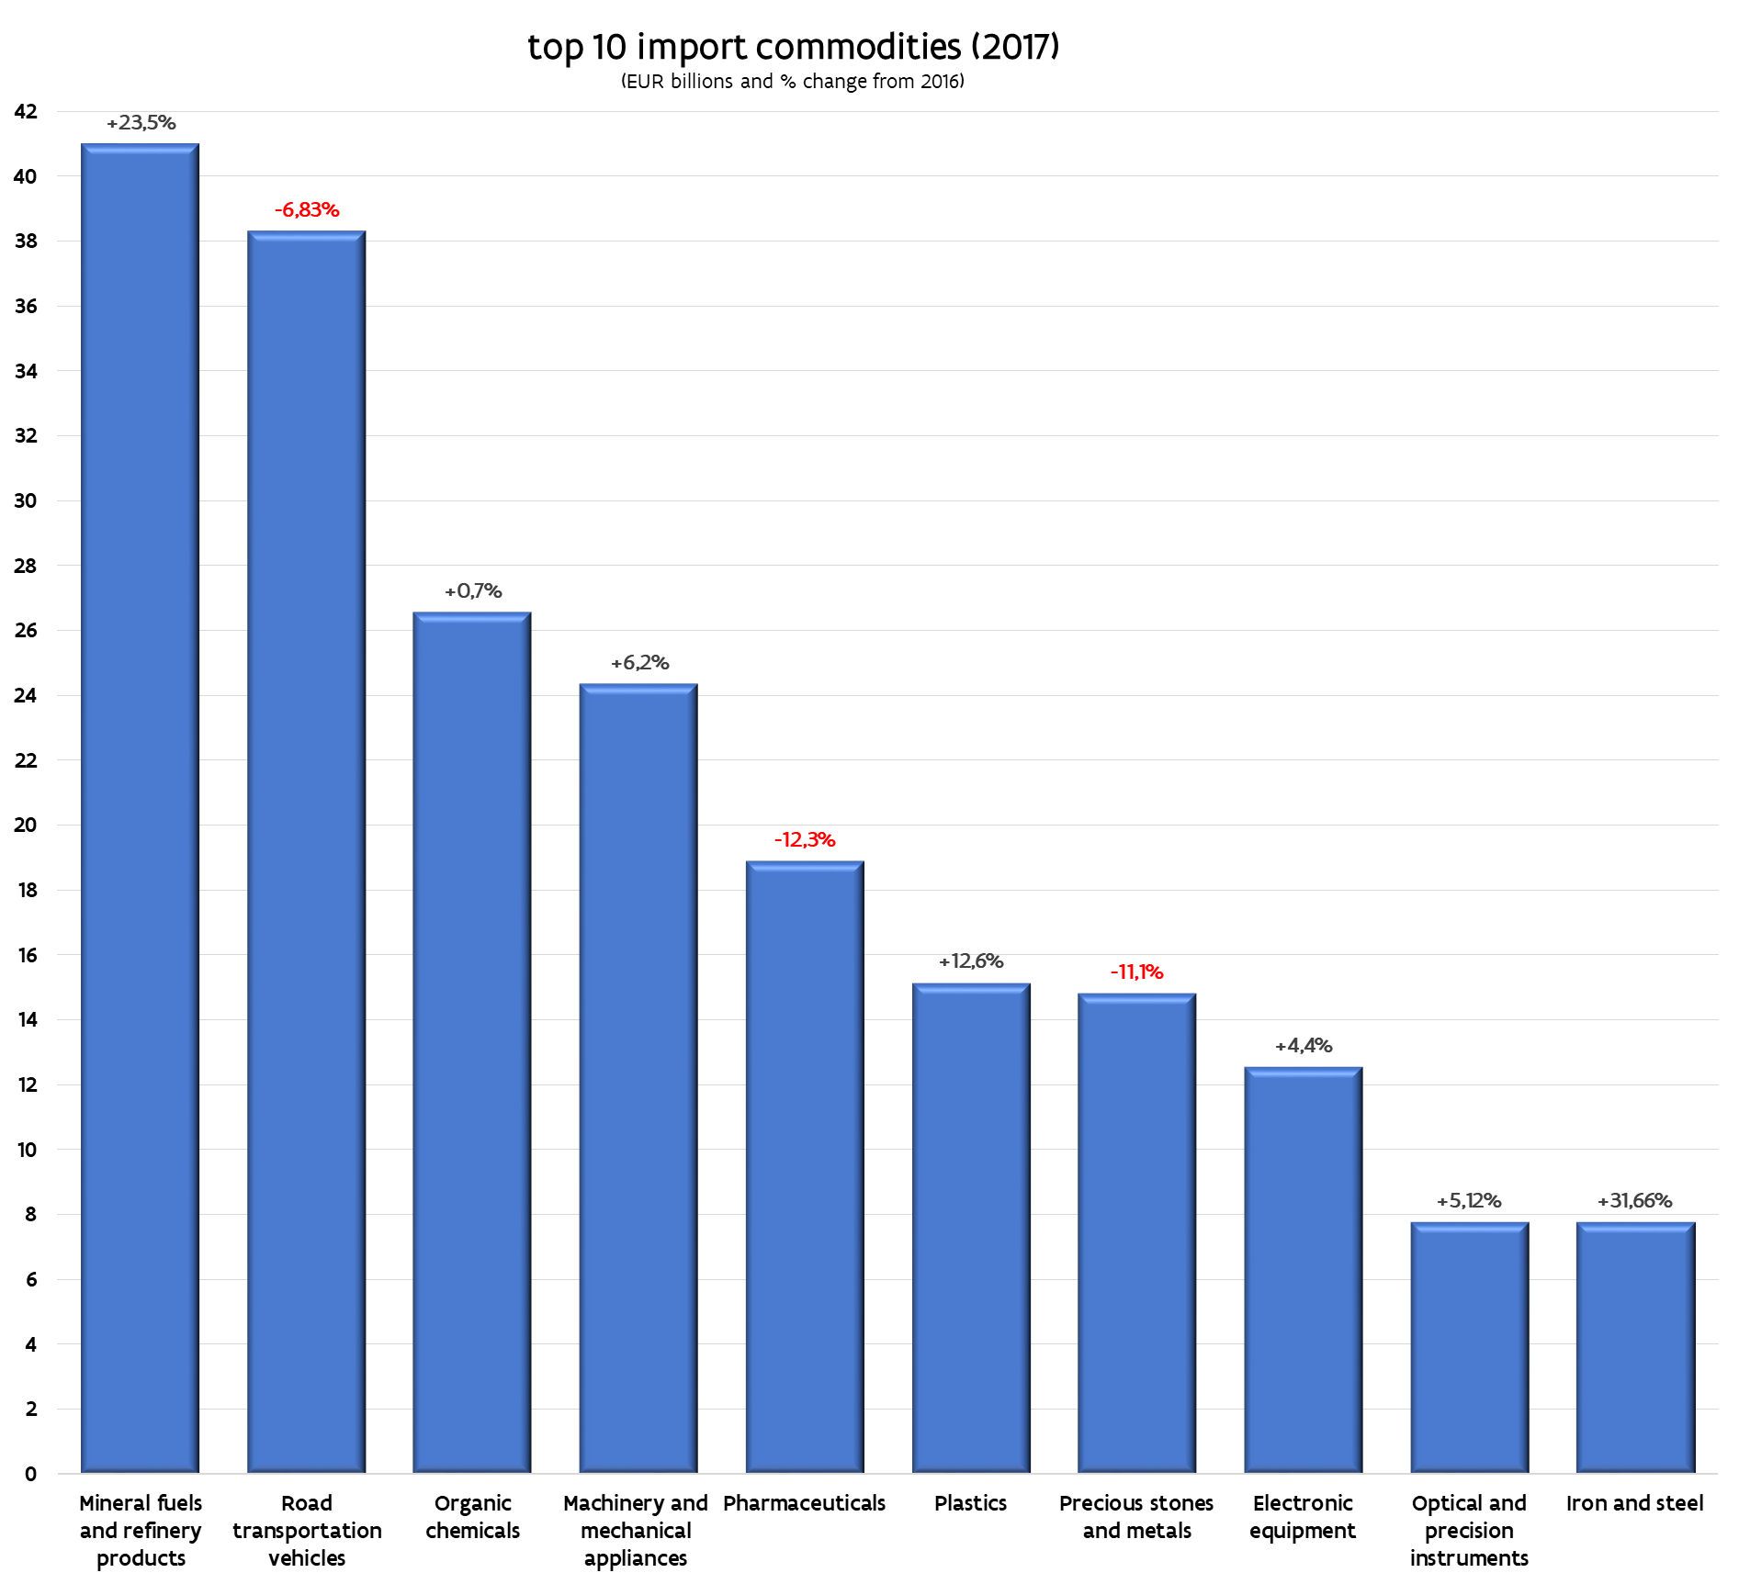

- The value of Flemish total trade in goods with a particular country (exports and imports combined), gives an idea of the main trading partners to Flanders.

  - The Netherlands continued to be Flanders’ main merchandise trading partner in 2017, which was largely due to robust import trade in mineral fuels and oil refinery products with the northern neigbours. Flanders did indeed import from the Netherlands about half (48.95%) of its worldwide purchases of those energy commodities.
  - Eight out of the Flemish region’s top ten trading partners are EU countries. Of all non-EU trading partners, only the United States and China claimed a top-ten spot.
FLEMISH BALANCE OF TRADE : surpluses and deficits
2017 saw he import value of mineral fuels by Flanders rise to EUR 41 billion, a 23.5% increase on 2016.
Imported fuels had a great bearing on the terms of trade with the Netherlands, our prime supplier country.
The following example gives a clear indication of the level of impact fuel imports exert on the balance of trade with the Netherlands: just imagine — for the sake of argument — that the fuel trade is altogether left out of the bilteral trade equation with the Netherlands. In that case, the 2017 balance of trade with our northern neighbours would still have tipped the 2017 trade balance in favour of the Netherlands, but that surplus would have totalled a mere EUR 1,8 billion instead of EUR 13.8 billion (with fuels trade taken into account).
Yet, the impact of imported fuels stretches beyond the balance of trade with just the Netherlands or with other major energy suppliers. It also affects the global trade performance of Flanders.
Putting aside mineral fuels, oil and refinery products when calculating the annual value of imports and exports in 2017, Flanders would have posted an even more substantial trade surplus of EUR 31.6, billion instead of the 17.7 billion surplus with fuels counted in.

Traditionally, Flanders has generated its major trade surpluses with its key international markets within the EU28 and has consistently done so with a varied array of export commodities. Germany (EUR 18.0 billion surplus), France (EUR 14.8 billion surplus), the United Kingdom (EUR 12.6 billion) and Italy (EUR 7.2 billion) are cases in point of such recurrent structural trade surpluses in 2017.
India also crops up in the league table of trade surpluses as the highest-ranking non-EU market to Flanders, which in 2017 recorded a EUR 3.1 billion trade-in-goods surplus, driven primarily by diamonds), with Switzerland following further down the list (EUR 2.6 billion surplus) and Nigeria, where Flemish trade in goods also showed a EUR 2.2 billion surplus in 2017.

The most sizeable trade deficit has invariably been with the Netherlands, posting a EUR 13.8 billion deficit, brought on in particular by mineral fuels as pointed out before), but trade gaps also appeared with
Ireland (EUR 10.4 miljard deficit, generated by chemicals / pharmaceuticals), the United States (EUR 7.2 billion deficit), with China (EUR 5.8 billion deficit), Japan (EUR 5.5 billion deficit), Russia (EUR 4.9 billion deficit) and Singapore; Flemish imports from the latter country outstripped exports to it by EUR 3 billion.

BRON: Instituut voor de Nationale Rekeningen (NBB), verwerking Cel Kennisopbouw FIT
N.B.: These figures, compiled according to the community concept, are provisional and therefore subject to change. Compilation according to the national concept is based on the transfer of ownership between resident and non-resident trade partners, whereas community concept compilation is based on export commodities crossing the country border (and therefore may include significant re-exports or imports for re-export). Intra-community trade aggregates include exports to and imports from the 27 other EU member states.

