South Africa bans Belgian poultry over avian flu

This article was originally published in Agra Europe
· 04 Jul 2017

South Africa has suspended imports of poultrymeat and live poultry from Belgium following recent outbreaks of avian flu in the country.

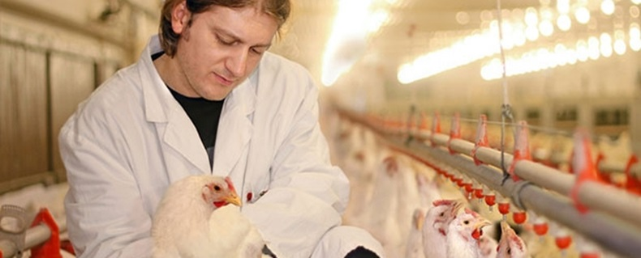

In a notification sent to the World Trade Organisation on Monday (July 3), South African authorities say any consignments packed after May 21 will be rejected and returned to Belgium or destroyed at the importer’s expense.

The temporary ban applies to live poultry, eggs and fresh and frozen poultrymeat. Heat processed products with the necessary documentation are exempted from the ban as are specific pathogen free (SPF) eggs.

South Africa is one of Belgium’s largest export markets outside the EU – taking more than 14,000 tonnes of Belgian poultrymeat last year.

Belgium looked to have brought H5N8 under control in April but the virus subsequently resurfaced and several new cases have been reported to the OIE in recent weeks.

Meanwhile, H5N8 avian flu has recently appeared in South Africa itself and the country’s own poultry products have consequently been banned by several neighbouring African countries.

https://iegpolicy.agribusinessintelligence.informa.com/agra-europe

