Site Selection Magazine's 2019 Executive Survey Top-10

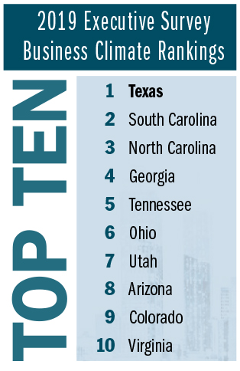

Bron:
https://siteselection.com/issues/2019/nov/business-climate-rankings-seven-straight-georgia-sets-a-record.cfm

