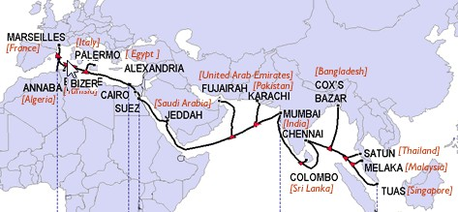
Bron: https://www.google.it/search?q=tlc+hubs+sicily+2016&rlz=1C1CHWA_nlIT645IT645&espv=2&biw=1366&bih=661&source=lnms&tbm=isch&sa=X&ved=0ahUKEwi09827jcrLAhVC6Q4KHej9DqYQ_AUIBygC&dpr=1#tbm=isch&q=SeaMeWe5&imgrc=w_b1Tvlt8Zc_QM%3A

