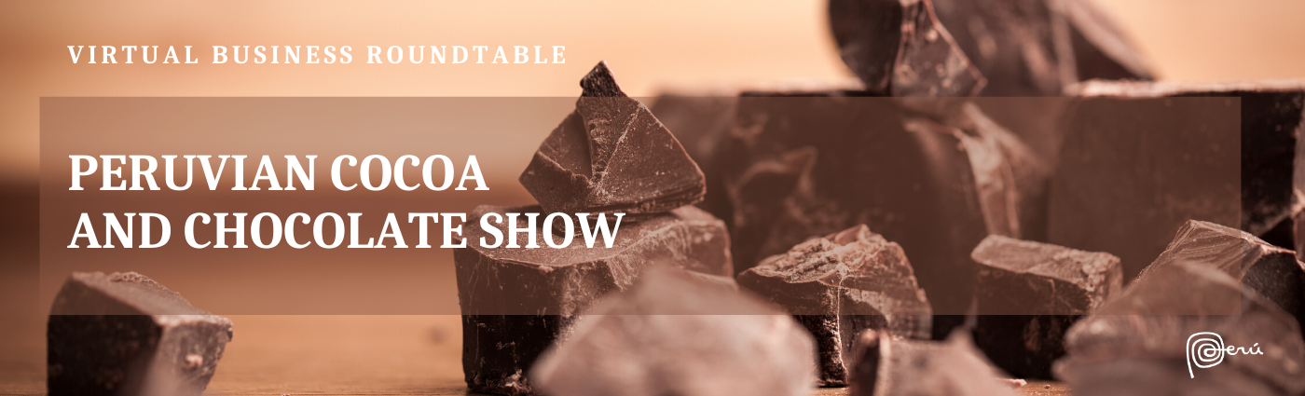

From 1-11 September 2020, PROMPERU, through its Commercial Office for the Benelux and Scandinavia, launches a virtual business roundtable connecting Peruvian producers of cocoa and chocolates with their Belgian counterparts, as part of the eleventh Peruvian Cocoa and Chocolate Show in Lima. Do not miss this excellent opportunity to get to know the producers directly through online speed business meetings.

Peru is home to many unique and wonderful varieties of cocoa, such as the aromatic Chuncho, the Amazonian ‘Cacao Nativo’, or the very rare Piura White, among numerous others. The cocoa bean, recognised by its floral, citric, and fruity notes, is embodied in the finest chocolates that are made from it. These unique attributes are provided by the diverse ecosystems where the cocoa is grown, the distinct fermentation processes with which they develop their characteristic flavour and aroma, as well as the natural drying processes.

The beans constitute the basis for obtaining a cocoa of excellent quality that works as the perfect ingredient to produce the finest chocolates. The chocolates have diverse presentations and cocoa contents, with dark chocolates going up to 100% cocoa. Other varieties are combined with sugar, milk and other ingredients such as Peruvian Superfoods, dried fruits, chestnuts, essential oils, and many more.

Come join this virtual business roundtable and embark on a digital journey through the different regions of the country, by discovering the varieties of the high-quality cocoa and chocolate that they produce. Participate, come in direct contact with the producers, and get to know the best of what Peru has to offer.

Register here
Registrations are open from 1-16 August 2020
More information: Ms Amora Carbajal, Director of the Commercial Office of Peru in the Benelux and Scandinavia, info@perutrade.nl

