Participants of the international conference in Brussels, 24-25 September
- Cooperative of Vegetables and Fruits Producers "SIELEC"
Cooperative "Sielec" is a producer’s group associating 68 producers, operation on 420 ha and growing ground vegetables. In the structure of plants dominates carrot, which production is about 6 000 tons , onion 2 000 tons, parsley 1 000 tons, beetroot 2 000 tons, celery 1 000 tons, potato 3 000 tons. So far we sell our products on the Polish and Romanian market. We have Global Gap and HACCP quality system.
Contact:
Mirosław Fucia
+48 509 832 180
spsielec@wp.pl
www.spsielec.pl
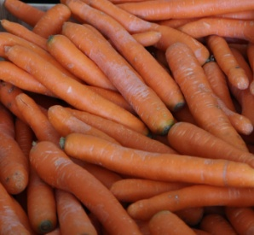

- Agropole
AGROPOLE company has been operating on the market since 1991. Our warehouse-manufacturing plant is located in Nieprowice, in Świętokrzyskie province, in the ecologically clean area of Ponidzie. Our company's activity is focused on dried vegetables and herbs, seasonings and herbal and vegetable mixes. We also offer our Clients roasted onion (fried onion) and stuffing for bakeries and catering. Through personal attention to the needs of our Customers, the company is building more and stronger position on the Polish market and abroad.
Contact:
Władysław Podraza
+48 41 356 11 95
biuro@agropole.pl
www.agropole.pl
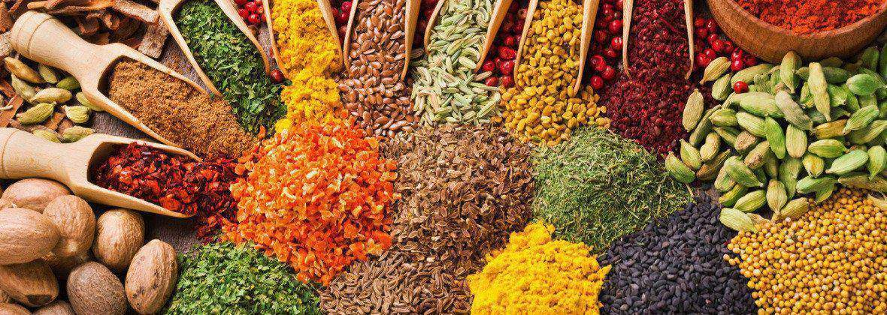

- Sad Sandomierski Ltd
The company Sad Sandomierski Ltd has been in the business regarding sales and producing 100% Natural Apple Juice from 2011. We are company who is exporting apples and apple juices to foreign countries – best price & quality guarantee. It is our pleasure to provide high quality products at very competent prices. We are best manufacturers of 100% Natural apple juice in the area.
Contact:
Konrad Floras
+48 601 234 588
marketing@sadsandomierski.pl
www.sadsandomierski.pl
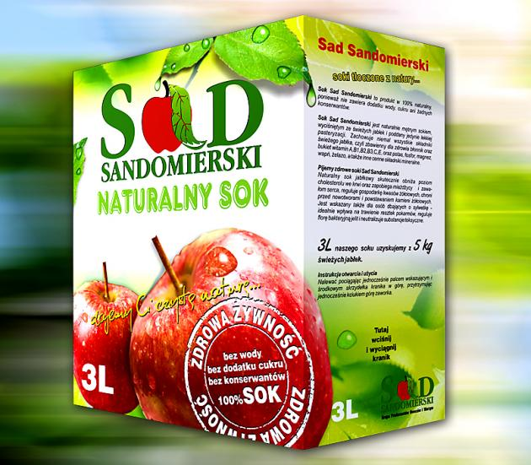

- OSM Opatów
OSM established in Opatów operates on the market since 1903. Dairy products produced by cooperatives were known throughout our country and abroad. Unfortunately, since 2007 the year for economic reasons cease the production of dairy products and the only flagship product became the candy cow milk, which produces the same year 40 of the OSM unchanged, using the same technology as formerly devices. Currently we manufacture candies in three flavors: milk, cocoa and cinnamon. The basic components of our fudge is: milk powder, sugar, corn syrup and vegetable fat.
Contact:
Roman Marchewka
667 374 555
r.marchewka@krowkaopatowska.pl
www.krowkaopatowska.pl
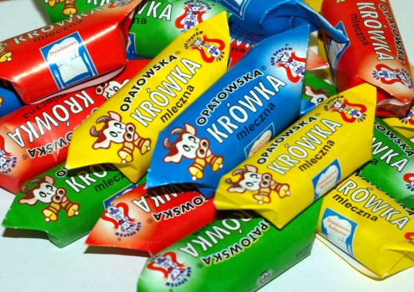

- Dairy Cooperative in Chmielnik
Dairy Cooperative in Chmielnik produces dairy products such as: butter, cottage cheese, mozzarella. The products are made in a traditional way for the consumer who values healthy food . Our firm is located far away from the industrial areas from, therefore our dairy products are the best quality.
Contact:
Jacek Bracichowicz
+48 603 657 207
Jacek_bracichowicz@poczta.onet.pl
www.osmchmielnik.pl
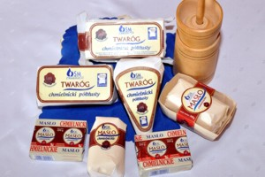
- MAT Cukierki
Our products have been enjoyed around the world for almost 15 years. From our very beginning until now, the mission of P.W.”MAT” Marzena Tkaczuk, based in Starachowice, has been to develop a wide range of sweets to delight the taste buds of generations of consumers. We make our products from trusted ingredients, according to the same tried and tested recipes. Our modern equipment allows us to ensure the highest quality.
Contact:
Marzena Tkaczuk
+48 509 020 641
marzena.tkaczuk@matcukierki.pl
www.matcukierki.pl
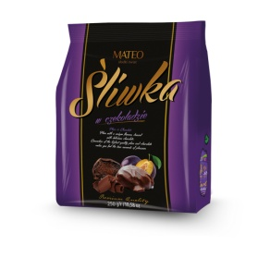

- Cooperative of Vegetables and Fruits Producers “Nadwiślanka”
The main product is the local sour cherry "nadwiślanka". Since 2010, part of the fruit is certified in the Food Quality System - Protected Designation of Origin.
Contact:
Bartłomiej Kwaśniak
+48 501 665 616
nadwiślanka@vp.pl
nadwislanka.com.pl
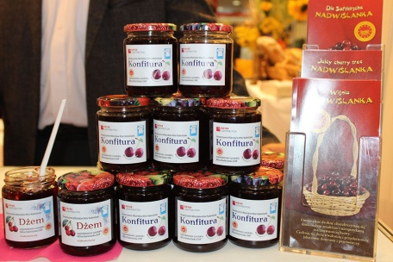
- Smaki Ogrodu, Bieliny

The Smaki Ogrodu company deals with the production of fruit and vegetable juices. We also provide service juice pressing. We can make them from yours or our fruits. Juices made by us do not contain water, sugar or any preservatives. We also sell juices made of fruit from our orchard - mainly from apples. Our juice is addressed to consumers who value healthy, high-quality food.
Contact:
Edyta Kot
+48 502 154 174
smaki-ogrodu@wp.pl
www.smaki-ogrodu.pl

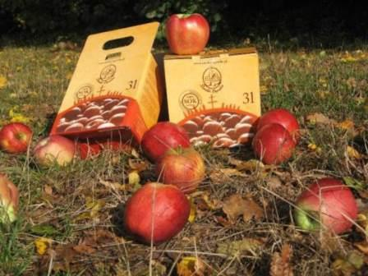

- MAT-MAS Tadeusz Matuszewski, Bęczków
MAT-MAS is a family-owned company, dealing with production of high quality cured meat products. The production process is based on homemade methods using natural spices, according to proven recipes and traditions of the region. The company has a very wide range of products. In the offer of the company there are all the types of sausages - thin and thick, ham, black pudding, gammon, bacon and others. The products do not contain preservatives, food coloring and flavor enhancers which combined with carefully selected meat from local growers, gives a unique taste.
Contact:
Damian Matuszewski
+48 724 272 298
damian.matuszewski@gmail.com
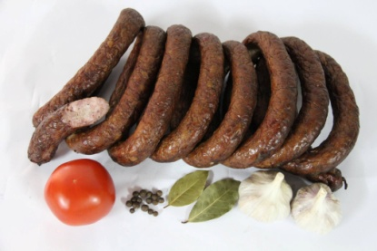
- Refal
Fruit and vegetable group Refal Ltd. was formed in 2009 on the initiative of the fruit growers of the Sandomierz County. The group is mainly concerned with storage, sorting and selling of apples; however, other fruit and vegetables are also on the offer.
As the group holds the Integrated Production Certificate and the Global G.A.P, our clients can be assured that our fruit and vegetables are of top quality.
Contact:
Stanisław Chachuła
+48 668 129 103
s.chachula@refal.eu
www.refal.eu
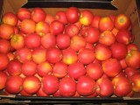
- Dobrowolski Bakery
The R. Dobrowolski Bakery is a family-owned company with traditions that has been operating in the Kielce market continuously since 1946. The lack of preservatives is also a guarantee of good taste. The base of the loaf is only rosin and natural acids, without the "chemistry" or flavor enhancers. In our offer you can find wheat bread, wheat-rye, wholemeal, multigrain, graham, and something sweet: croissants, halva, sweet rolls with natural ingredients.
Contact:
Halina Dobrowolska
+48 504-085-464
bozena.dobrowolska@op.pl
www.piekarniadobrowolski.pl
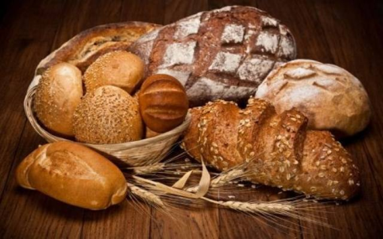
- Zakład Przetwórstwa Owoców Sambor
Fruit processing plant SAMBOR LLC is located in the natural orchard basin in Sandomierz Valley. An extension of our enterprise, which annual production capacity at the beginning of our activity was 100 tones of apples, allow us now to produce:
- 10 000 tones of apple juice concentrate
- 2 000 tones of colorful fruit concentrate
- 30 000 tones of NFC
In our plant 600 tones of apples and 250 tones of colorful fruit are transforming. The enterprise own two independent production lines, which allow us to produce two products at the same time.
Contact:
+48 15 644 50 14
info@sambor.co
www.sambor.net.pl
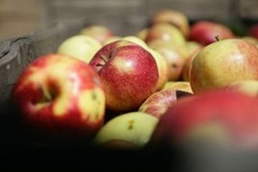
- Manufactory of Cured Meat Products in Wąchock
The Manufactory of Cured Meat Products in Wąchock is a family-owned company. The origins of the plant's operations took place in the 1930s. The plant offers a wide portfolio of products from various price segments. As a company dynamically developing and following market trends and consumer needs, Zakład Wyrobów Wędchiarskich in Wąchock offers traditional products without any enhancers. The products have been repeatedly appreciated in nationwide competitions.
Contact:
Paweł Nowak
+48 602 793 718
Pawel.nowak@wedlinyzwachocka.pl
www.wedlinyzwachocka.pl
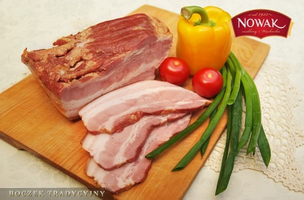

- Farma Łukasików
The farm is engaged in the production of dairy products, among others: butter, cottage cheese, natural cheese, unpasteurised fresh milk, natural yoghurts. The specialty of the farm is Buncok Strzałkowski - cheese in various varieties. We prepare all dairy products on your own farm!
It is a guarantee that the food purchased from us is healthy, natural and always fresh. We obtain milk from cows that are under the constant supervision of a veterinarian. We meet the necessary EU requirements. We use the right equipment for production, we use proven methods for home-made dairy products.
Contact:
Teresa Łukasik
+48 692 954 301
mlekostrzalkow@wp.pl
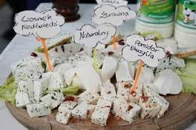

- „Słowacki” Hotel Medical SPA
"Słowacki" Hotel Medical SPA It’s a place where we do our best to make our guests feel special and comfortable. The hotel is surrounded by greenery - with one side adjacent to the Spa Park, on the other - has its own unique garden. Comfortable and spacious rooms will satisfy even the most demanding guests. Excellent cuisine and professional service are another of our strengths. It's hard to find a better place to regenerate, improve health and beauty and relax. As the first Hotel SPA in Poland we use from natural deposits
of First Thermal Sulphurous Waters!
Contact:
Paweł Korczak
+48 608 508 437
Korczak.p@interia.pl
www.slowacki.busko.pl
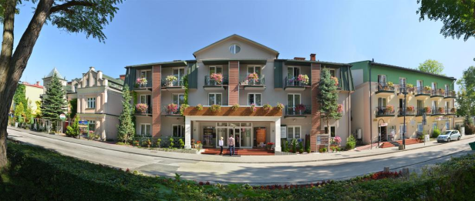

- Bristol**** Art & Medical Spa Hotel
Bristol**** Art & Medical Spa Hotel is a luxury health complex located in the city centre of Busko - Zdroj, where art goes together with therapy and therapy is art. Hotel Bristol **** offers a variety of SPA treatments, which will help you relax and regain your physical and mental balance. Recreational activities will strengthen the whole body, and beauty rituals will restore your skin firmness and shine. The therapeutic sulphuric treatments used at Bristol Hotel **** Art & Medical Spa have regenerative, anti-inflammatory and anti-rheumatic properties. Find out for yourself and see the power of nature offered by Busko-Zdrój.
Contact:
Karina Przybyło-Kisielewska
+48 607 077 319
k.kisielewska@bristolbusko.pl
www.bristolbusko.pl
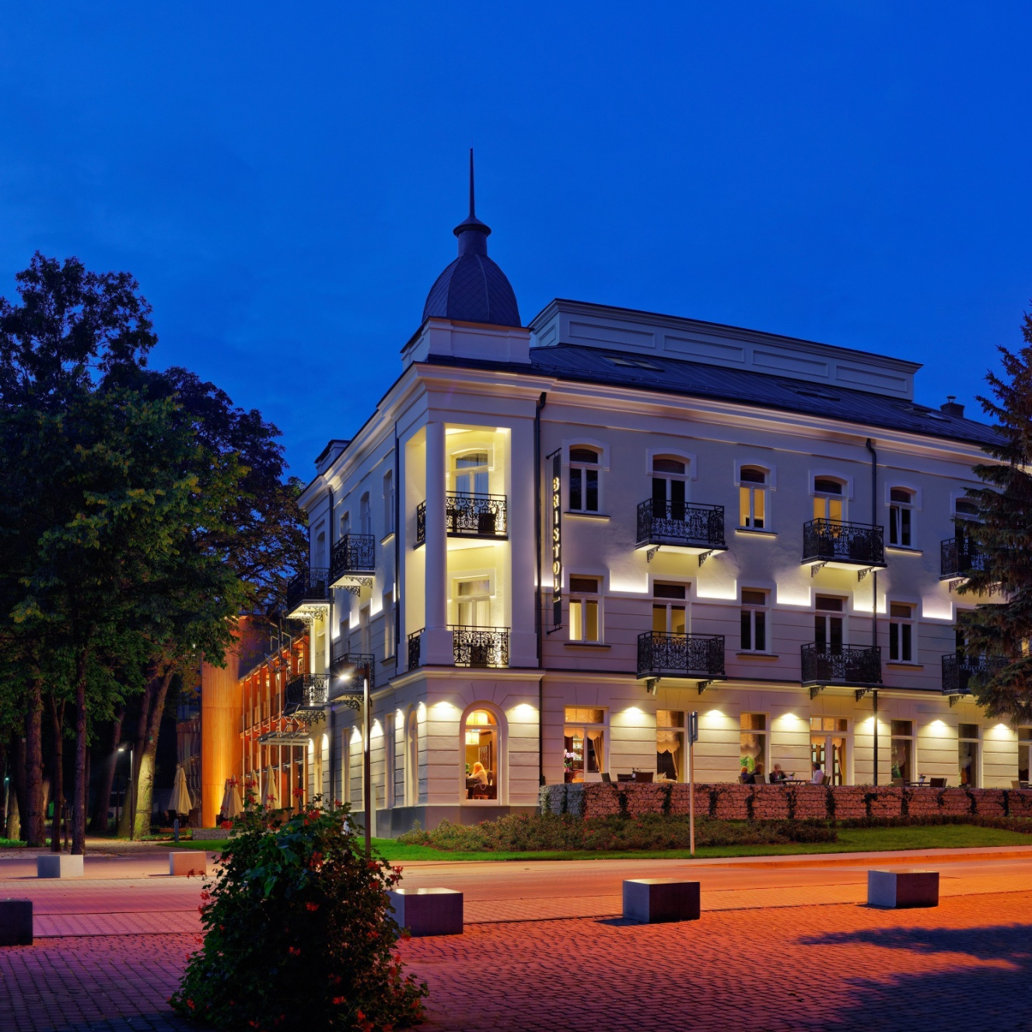

- Senator Hotel ***
The Senator Hotel is situated in the Świętokrzyskie Region in Starachowice. We currently have 53 new rooms, including 5 unique boutique apartments, awarded with the 2015 Success Statuette of the Year, Drem Spa Center, Thermal Center and Atrium Restaurant.
Contact:
Anna Pająk
+48 694 455 220
annapajak@h-s.pl
www.h-s.pl
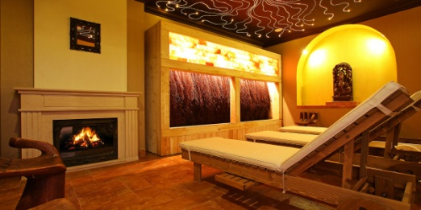

- Uroczysko Spa & Business Hotel
Situated in pine tree park near Cedzyna nature reserve, at the heart of the oldest mountains in Europe - the Świętokrzyskie Mountains. The unique location makes it a perfect place not only for family vacation, but also for conferences, business banquets and symposia. we offer 110 rooms and suites, 7 conference halls, a spacious exhibition lobby, air-conditioned restaurant; as well as, Wellness & SPA centre. Thanks to the rustle of trees and daily morning concert of birds our guests can experience an unforgettable closeness to nature.
Contact:
Marcin Szczałuba
+48 664 198 28 10
marcin_szczaluba@interia.pl
www.hotel-uroczysko.com.pl



