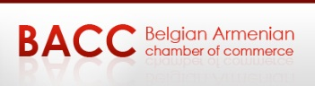
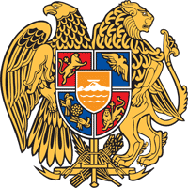
Embassy of Armenia to the Kingdom of Belgium
Trade Representative of the Republic of Armenia to the EU

The Embassy of the Republic of Armenia to the Kingdom of Belgium,
the Trade Representative of the Republic of Armenia to the EU together with the
Belgian Armenian Chamber of Commerce in collaboration with AWEX, FIT, AGORIA,

have the pleasure to invite you to the Business Forum

ARMENIA-BELGIUM
“NEW OPPORTUNITIES AT THE CROSSROAD OF EAST AND WEST”

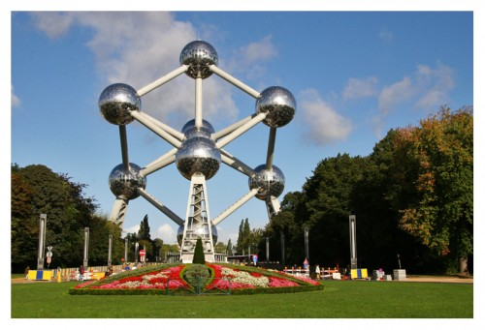
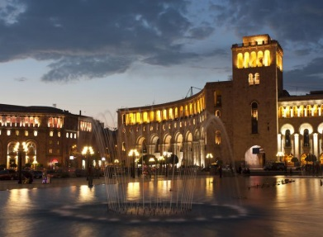
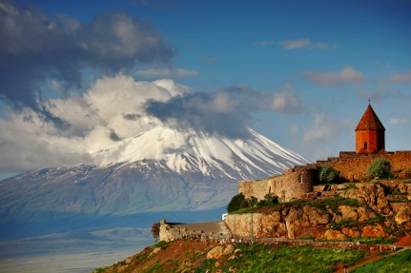

- The Business Forum is an excellent opportunity for Belgian companies to gain insight on the business climate in Armenia, particularly after the joining Eurasian Economic Union.
- The focus will be made on key sector such as Research and Innovation, ICT and Tourism
Practical information

When? December 1, 2017 from 15:30
to 18:15 which will be followed by Armenian Wine tasting / Networking hosted by Armenian Brandy and Wine a division of WITH US sa-nv

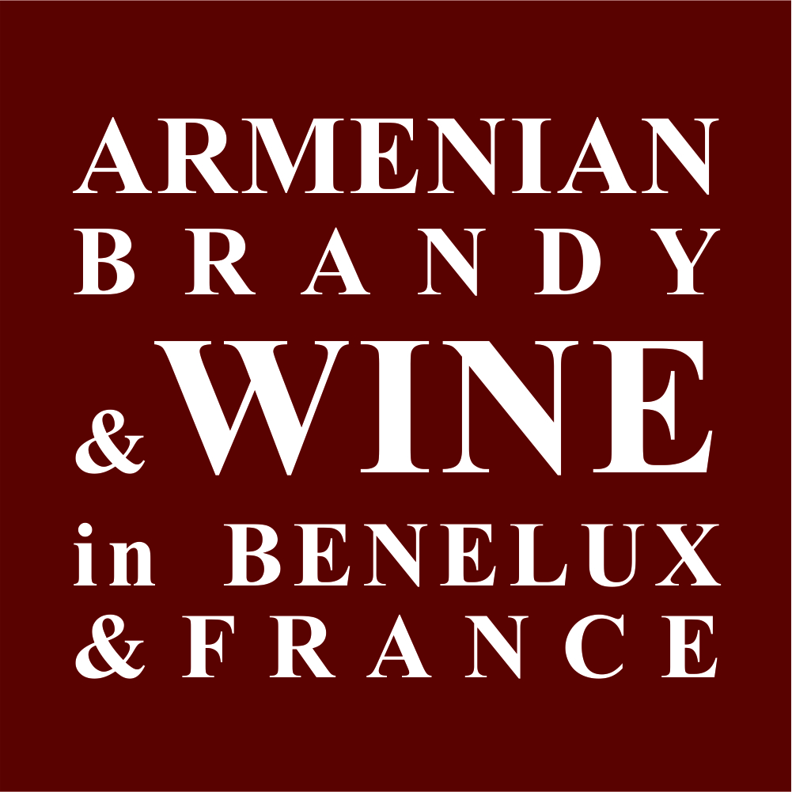

Where? : Manos Conference Center, Chaussée de Charleroi 135, 1060 Brussels, Belgium
Please find enclosed the event programme.

