Encouraging an Indonesian Hydrogen Utilization Ecosystem, BRIN Maps a National Strategy by 2060
Indonesia needs a strong commitment to realize utilization hydrogen in the homeland. To encourage this, the National Research and Innovation Agency (BRIN) has conducted a study related to the national hydrogen strategy roadmap.

"BRIN has identify hydrogen needs until 2060. What we emphasize most on this roadmap is the need for an ecosystem that supports implementation hydrogen in Indonesia," explained Eniya Listiani Dewi, Principal Expert Researcher of the BRIN Energy Conversion and Conservation Research Center, after launching the Roadmap National Hydrogen Strategy, at the Indonesia International Hydrogen Summit 2023, at St. Regis Hotel, Jakarta, Wednesday (21/6).

He said, this roadmap lays out a hydrogen energy roadmap which is divided into Three segments, namely the pilot project or demo plant segment, development and market introduction, and market penetration, and effects on economic value added.

"In the future, Our economy will be supported not only by oil, but also by hydrogen. Because Hydrogen can be used in various sectors, from the power generation sector, industry especially the petrochemical industry, housing, and transportation," said Eniya who is also the President of Indonesia Hydrogen Energy Fuel Cell.

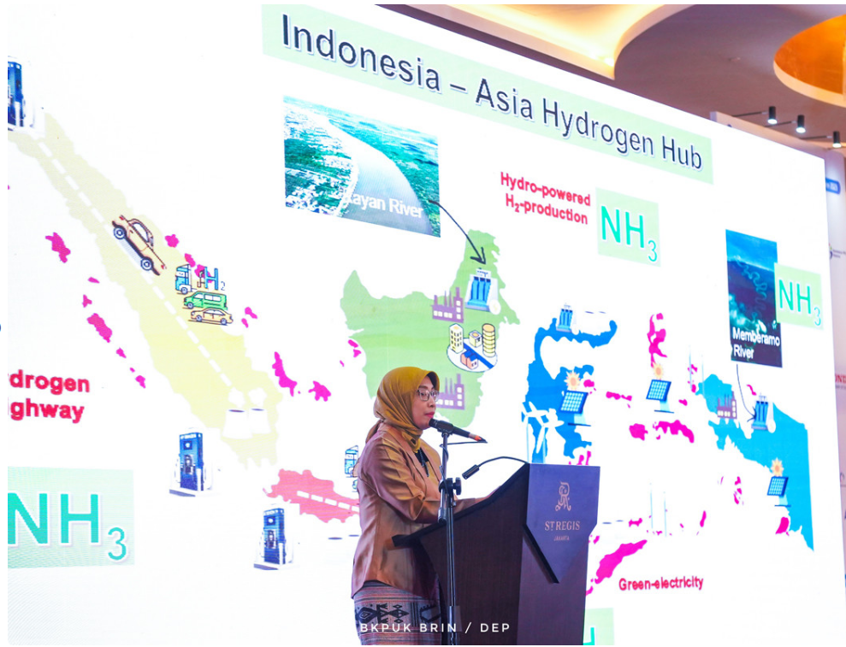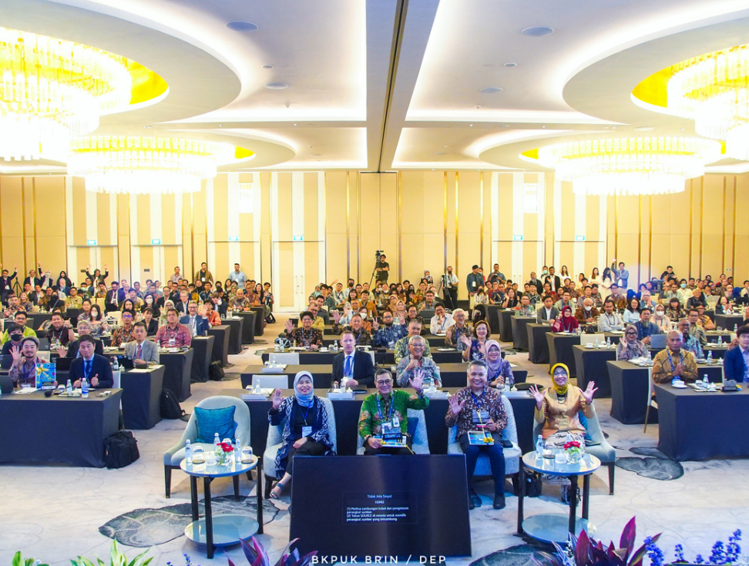

Pictures: Indonesia International Hydrogen Summit (IIHS) 2023

This soft launch, he continued, will be readjusted to the roadmap according to industry needs. From the Ministry of Energy and Mineral Resources, according to him, it is necessary to make a national hydrogen strategy that also includes not only hydrogen potential, But also the chain of production, distribution, and utilization of hydrogen in Indonesian.

He said there are already many industries that are interested in investing in Indonesia, but questioning the government's commitment. "This meeting is a trigger for Declaring the commitment of various parties to build a hydrogen ecosystem," he said.

Further He revealed that there have been 20 projects from industry that carry out pre-feasibility studies on hydrogen technology, both in Sumatra, Kalimantan, Sulawesi, Java, Sumba, NTT, and so on Papua. "But when going to the feasibility study, they (industry) asked, Is there a roadmap? Its commitment? Here's what we need to start from now," he stressed.

To realize the use of hydrogen energy takes time. First is a commitment from the government, with a road map. Then it is required regulation, clear standards, including incentive mechanisms.

If you have to Starting the utilization of hydrogen, the most potential is in the industrial sector. That is by producing green hydrogen, although still Small scale because the price is still relatively high.
"I'm sure The price turning point will fall in 2030, but not Maybe we wait to start harnessing hydrogen until 2030, We might become a country that is left behind again," he said.

"Then Carbon capture either by carbon capture method or filter in industry. So the term carbon recycling is important," he added.
Sector The next potential is the power generation sector, then the sector transportation, and household.
"In Japan It took 10 to 20 years for people to understand hydrogen. So, in Indonesia, we must start now," he said.
It will require an effort to implement decarbonization in Indonesia (TNT).

Source: BRIN - Encouraging Hydrogen Utilization Ecosystem, BRIN Maps National Strategy on Hydrogen by 2060

