The EIB in Bulgaria in 2017

Financing provided by the European Investment Bank (EIB) in Bulgaria reached EUR 256m in 2017. Over the last five years (2013-2017), the Bank has provided funds amounting to some EUR 1.7bn to finance investment projects important for Bulgaria’s economic development. The EIB’s operations in Bulgaria cover all major economic sectors, ranging from basic infrastructure such as transport, communications, energy and the environment to manufacturing and services, including support for small and medium-sized companies through local financial institutions and the development of a knowledge-based economy.

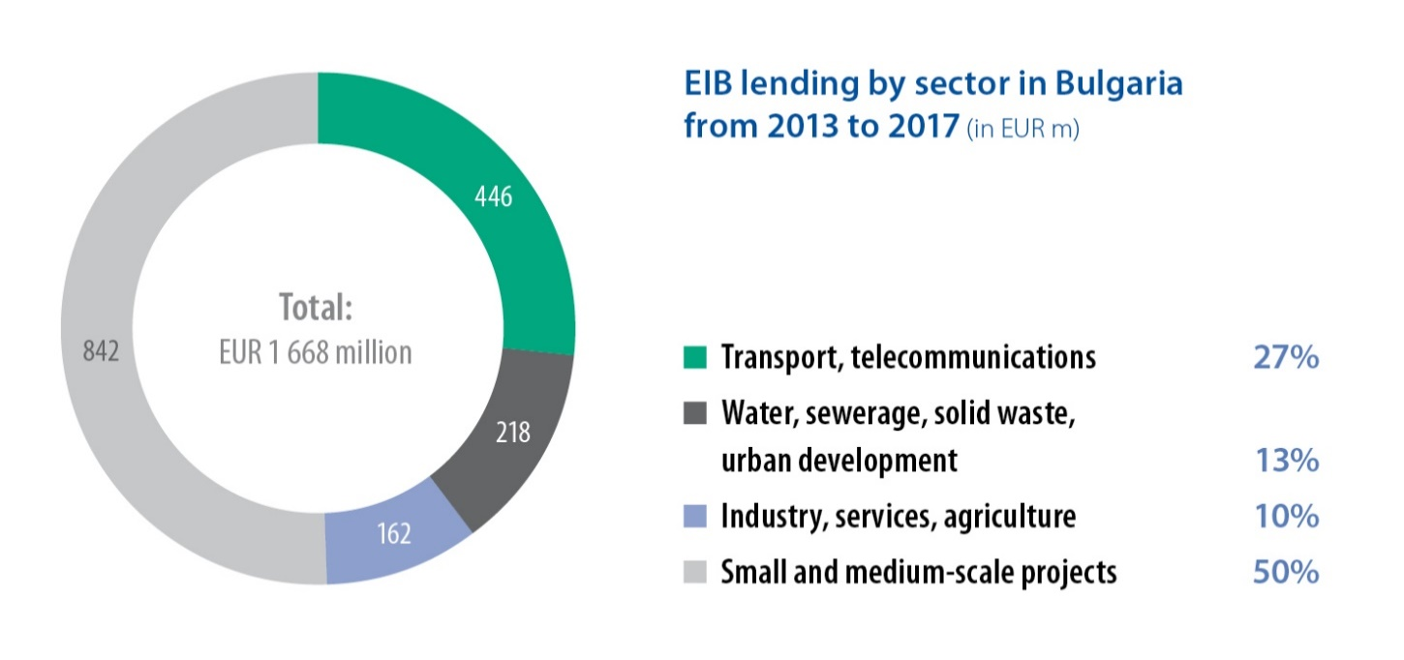

Financing under the European Fund for Strategic Infrastructure (EFSI)

The EIB provided a EUR 31m loan to Oliva AD – Bulgaria’s leading sunflower oil producer and grain trader. This was the first EIB loan to a Bulgarian private company to benefit from the support of the EU budget guarantee under the European Fund for Strategic Investments (EFSI), the financing component of the Investment Plan for Europe (IPE). Oliva AD is a successful local operator in the sunflower market that has continuously modernised its assets and improved competitiveness. The company is using the EIB loan to finance the construction of a new sunflower oilseed production plant and storage and logistics facilities in the Beloslav municipality near Varna.

The EU bank granted a EUR 100m EFSI-backed loan to Biovet - a subsidiary of Huvepharma International - to finance a planned increase of production and R&D activities in the area of animal health. While it serves primarily the company itself, the loan also contributes to the improvement of agriculture, farming and agro-food business, a key component of Bulgaria’s economy. This operation will strengthen the competitiveness of a leading company in the veterinary sector in Bulgaria reinforcing Europe’s leading position in the animal health market. This is important as animal health is a key element of the EU farming industry and an area of concern for all European citizens.

Promoting digitalisation

The EIB supported the research, development and innovation (RDI) activities of Software AG in relation to new software products used for the digitalization of business processes. The project, which involves investments in several EU Member States, focuses on software applications related to the Internet of Things and the management of big data. With an amount of EUR 23m, the loan supports the upgrade of internet interconnectivity in Bulgaria.

Fostering Municipal Transport

The EU bank signed a loan agreement of EUR 56m to finance the construction of the first stage of Sofia Metro line 3, including a 7.8km long twin-track metro line, eight metro stations, a train depot and the supply of 20 metro trains and a control system. This investment is enhancing the public transport network of the Bulgarian Capital in line with the EU priority to promote sustainable transport. It helps reduce reliance on private cars and increase the share of public transport, thereby contributing to climate change mitigation and positively impacting the economic and social development of Sofia.

Support for SMEs and midcaps

In 2017, the Bank concluded EUR 40m worth of intermediated lending with two EIB partner financing institutions, further improving the access of Bulgaria SMEs and municipalities to EIB financing:
- A EUR 30m intermediated loan to Raiffeisen Leasing Bulgaria. The loan will allow Raiffeisen Leasing Bulgaria to better address the needs of SMEs and midcaps, which are the backbone of the Bulgarian economy. It is expected that more than 150 companies operating in Bulgaria in agriculture, manufacturing, transportation and storage will benefit from this loan.
- A EUR 10m intermediated loan to Procredit Bank to co-finance smaller projects implemented by SMEs and midcap companies in Bulgaria.

- SME Initiative in Bulgaria, signed in 2016, was successfully launched in early 2017 with concluded guarantee agreements with 10 partnering banks in Bulgaria. As of the end of 2017 more than 2,000 individual SME loans in Bulgaria were originated under the program providing total financing of approx. EUR 300mn to small business, thus reaching 50% utilisation in the first year of implementation. Approximately 10% of this financing (EUR 30mn) was used to support R&D and innovation in small businesses in the country.

The European Investment Fund

The European Investment Fund (EIF) is the specialist arm of the EIB, providing risk financing solutions for financial intermediaries to support SMEs and mid-caps and foster innovation in Europe. In 2017 it committed EUR 9.34bn in support of business, through which approximately EUR 35.4bn of additional capital will be leveraged.

By business line, EIF committed a total of EUR 3.3bn in 146 equity transactions with early and growth stage funds, which is expected to raise EUR 15.7bn of additional commitments. On the guarantees side, it committed EUR 5.9bn in 169 transactions, which acted as a catalyst in generating EUR 18.9bn of new loans for SMEs. EIF’s support for micro and social enterprises totalled EUR 110m, creating a total loan volume of more than EUR 685m. Overall, more than 202 000 SMEs and mid-caps were supported by EIF in 2017, sustaining some 1.5 million jobs.

In Bulgaria in 2017, EIF committed EUR 49m in 4 guarantee operations, aimed at raising EUR 327m.

The potential investment triggered by the EIB Group in Bulgaria thanks to EFSI transactions totalled EUR 1.58bn up to the end of 2017. In this regard, in 2017 EIF signed one EFSI transaction with an aggregate EIF commitment of EUR 22m, aimed at mobilising EUR 390m in risk financing for SMEs.

For more information: http://www.eif.org/

The EIB at a glance

The EIB is the EU’s long-term lending institution and is owned by the EU Member States. It makes long-term finance available for sound investment, contributing to growth, jobs, regional convergence and climate action in Europe and beyond. In 2017, its total financing amounted to EUR 70bn.

To ensure maximum impact, the EIB lends to sound projects, combining EU funds with its loans and advising on technical and financial aspects.

The EIB is supporting Europe’s economic recovery by implementing the European Fund for Strategic Investments (EFSI). By the end of 2017, the EIB Group had committed EUR 51.3bn under EFSI, mobilising total investment of EUR 257bn, or 82% of the target of EUR 315bn over three years.

The EIB’s activities around the world reflect the EU’s external priorities. Outside the EU, the EIB is active mainly in the pre-accession countries and eastern and southern neighbours. It also operates in African, Caribbean and Pacific countries, Asia and Latin America – supporting local private sector development, social and economic infrastructure and climate action projects.

The EIB is financially autonomous and raises the bulk of its lending resources on the international capital markets through bond issues.

Overall EIB Group achievements in 2017
A total of EUR 78.2bn in financing by the EIB Group. | By end of 2017, the EIB Group had approved EUR 51.3bn under EFSI for close to 720 financing transactions, which are expected to support investment of EUR 257bn.
EUR 13.8bn  EIB Group support for innovation and skills, including education and digital infrastructure. | EUR 29.6bn  EIB Group support for SMEs and mid-caps – the biggest share of our lending.
EUR 18bn supporting key infrastructure in transport and energy as well as urban infrastructure. | EUR 16.7bn for environmental projects supporting resource-efficiency and sustainability.

For further information on the EIB in Bulgaria: www.eib.org/bulgaria

Press contacts:  Dušan Ondrejička  Tel.: +352 4379-83334  Email: d.ondrejicka@eib.org  Press Secretariat  Tel.: +352 4379-21000  Fax: +352 4379-61000  Email: press@eib.org  www.eib.org/press | General contacts:  European Investment Bank  98-100 boulevard Konrad Adenauer  L-2950 Luxembourg  Information Desk  Tel.: +352 4379-22000  Fax: +352 4379-62000  Email: info@eib.org  www.eib.org

