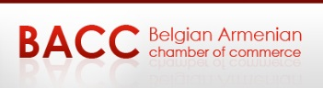
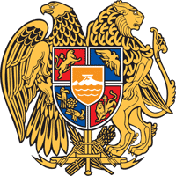

ARMENIA-BELGIUM
Embassy of Armenia to the Kingdom of Belgium
Trade Representative of the Republic of Armenia to the European Union
NEW OPPORTUNITIES AT THE CROSSROAD OF EAST AND WEST BUSINESS FORUM
Brussels, 1ST December, 2017

Venue: Manos Conference Center, Chaussée de Charleroi 135, 1060 Brussels
15:30-15:45 Registration
15:45-16:00 Welcoming remarks, by
- H. E. Mr. Tatoul MARKARIAN, Ambassador of the Republic of Armenia to the Kingdom of Belgium
- Mr. Valery Safarian, President of Belgian Armenian Chamber of Commerce
16:00-16:15 Session I: “New opportunities at the crossroad of East and West”
- Mr. Avetis Hovhannisyan, Investment Director, Development Foundation of Armenia
Questions and Answers
16:15-17:00 Session II: “Digital Economy”
- Mr. Bagrat YENGIBARYAN, Director, Enterprise Incubator Foundation
- Mr. Ashot ARZUMANYAN, Partner SMARTGATE VC
Questions and Answers
17:00-17:15 Coffee Break - Networking
17:15-18:00 Session III: “Tourism”
- Mr. Mekhak APRESYAN, First Deputy Chairperson of the State Tourism Committee of the Republic of Armenia
- Mr. Bernard Coulie, Honorary Chairman of Belgian Armenian Chamber of Commerce
Questions and Answers
18:00-18:15 Closing remarks, by
- Mr. Robert Harutyunyan, Deputy Minister of Foreign Affairs of the Republic of Armenia
18:15-20:00 Armenian Wine tasting / Networking hosted by Armenian Brandy and Wine a division of WITH US sa-nv
