CONSTRUMA – 2016
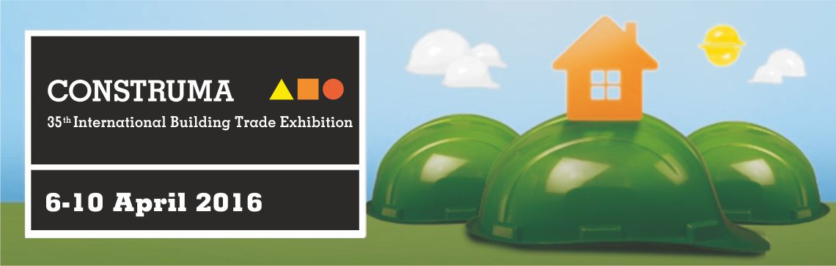

The trade show at a glance
Venue: Budapest, Hungexpo Fairground
Show organizer: HUNGEXPO, 1101 Budapest, Albertirsai út 10, www.hungexpo.hu
Products/Services: bathrooms, construction equipment, decoration, garden equipment, interior design, plants for water treatment, pools, prefabricated houses, primary materials, quality control
Frequency: Annual
Date and duration: 6-10 April, 2016
Scope: International – open-to-all-show
Exhibitors: 647 exhibitors where presented
Participation by FIT at EXPO: None
Visitors: The organization is expecting around 53.000 visitors.
Website: http://construma.hu/en/mainpage (available in English)
Exhibitor’s list: http://construma.hu/en/online-catalogue
Next edition date: N/A yet, probably around the second weekend of April 2017.

Leading trends and overall observation judgement
Over the recent years, the CONSTRUMA Fair has become a must-see forum. Thanks to continuous developments, by now it covers the entire spectrum of home building from purchasing the real estate through construction until to interior design. The assortment includes following subject fields:
- CONSTRUMA (construction industry)
- RENEO (renewable energy, building engineering)
- HOMEDesign (interior decoration, design)
- CONSTRUMA GARDEN (landscaping, garden planning)
- FLAT FAIR (second-hand and new real estate)
- Co-exhibition: LIGNO-NOVUM (wood industry)
Furthermore the construction sector in Hungary is still an opportunity branch and this trade fair was a perfect reflection of this trend. Fully occupied exhibitors booths, increasing number of visitors and an international mindset.

Importance of the trade show
Construma is considered one of the most important exhibitions for the construction industry in Central and Eastern Europe. Many international exhibitors present a variety of new products, innovations, technologies, solutions and services of the construction industry. In separate parts of the fair there are also presentations on issues such as marble, stone and granite, doors and windows, lighting and renewable energy.

Trade show facts
The fair was both accessible for professionals as well for general visitors. On the first couple of days (international professional day) visitors were only allowed to enter the exhibition with an invitation or professional ticket.
The number of visitors will most certainly increase in comparison with previous years. They expect around 53.000 visitors. Most of the foreign visitors came from The Czech Republic, Germany, Slovakia, Ukraine and Austria.

Recommendation
The construction market is still increasing in sales figures therefor it could be interesting that more Flemish organizations are willing to send over representatives to promote their construction products and services in Hungary. During this year’s edition there were two Flemish companies which exhibited their products.
