International Travel & Tourism Exhibition – 2016 (Budapest)
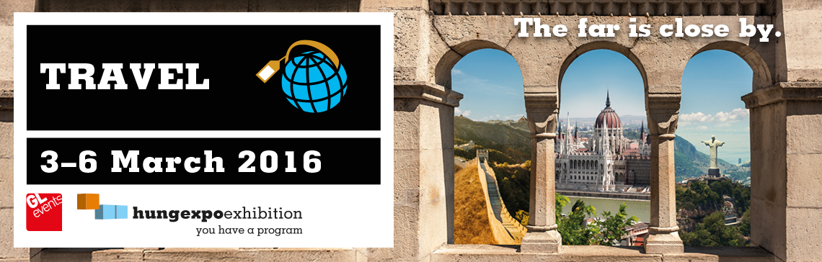

The trade show at a glance
Venue: Budapest, Hungexpo Fairground
Show organiser: HUNGEXPO, 1101 Budapest, Albertirsai út 10, www.hungexpo.hu
Products/Services: Travel agencies, hotels, tourism organizations and public tourism institutions.
Frequency: Annual
Date and duration: 3-6 March, 2016
Scope: International – open-to-all-show
Exhibitors: 382 exhibitors were present from 40 different countries.
Participation by FIT at EXPO: None
Visitors: Attendance figures: last year 40.000, the edition of 2016 will have slightly more visitiors. The large mayority of them are Hungarian, although there were also a small amount of foreign visitors from surrounding countries like Serbia, Slovakia,…
Website: http://utazas.hungexpo.hu/en (available in English)
Exhibitor’s list: http://utazas.hungexpo.hu/en/online-catalogue
Next edition date: N/A yet, probably again in the first weekend of March 2017.

Leading trends and overall observation judgement
The tourism sector in Hungary is still increasing every year and is a booming sector. Both for in and outbound tourism. This trend was also clearly noticeable at this year’s fair and is a logical outcome if you consider following data:
Generally in the fourth quarter of 2015, the number of foreign visitors to Hungary and the amount of their expenditures grew by 1.2% and 4.4% respectively compared to the fourth quarter of 2014. Meanwhile, Hungarian people made 2.4% more trips abroad and spent 5.7% more. Furthermore in 2015, the number of foreigners arriving in Hungary grew by 5.1%, the number of Hungarians travelling abroad by 5.7% and the balance of passenger services by 11% - to HUF 975 billion (EUR 3.1 billion). (KSH: HUNGARIAN CENTRAL STATISTICAL OFFICE, 2016)

Importance of the trade show
The expo had both a national and regional importance for the tourism sector. Many international exhibitors were promoting and representing their country to attract more Hungarian visitors.

Trade show facts
The fair was both accessible for professionals in the travel sector as well for general visitors. On the first day of the fair (international professional day) visitors were only able to enter the exhibition with an invitation or professional ticket.
The international travel exhibition took place in the largest pavilion of the HUNGEXPO with a occupied capacity of 20.000 sq.m. The number of visitors will certainly be higher than last years’ 40.000.

Recommendation
This fair is a great opportunity for Flemish travel agencies, hotels and other tourism related business activities to promote their business in Hungary or even Central East - European Countries (CEECs) in general. Unfortunately there was no participation from Flemish companies or national tourist organizations, while the tourism industry in Hungary is a prosperous sector.

Contact Info
HUNGEXPO C.Co. Ltd., International Travel & Tourism Exhibition
Address: H-1101 Budapest, Albertirsai út 10
Letters: H-1441 Budapest, P.O. Box 44
Fax: +36-1/263-6066
E-mail: info@hungexpo.hu
Facebook Social Media Page: https://www.facebook.com/utazaskiallitas/timeline

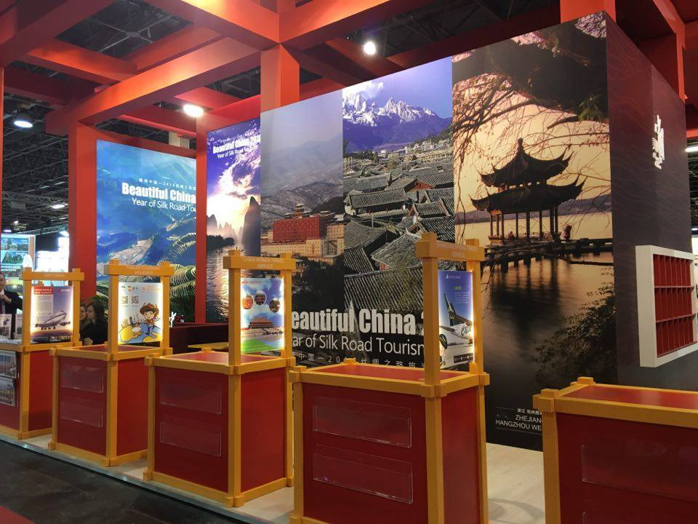
Picture 1: Impressive Chinese Pavilion

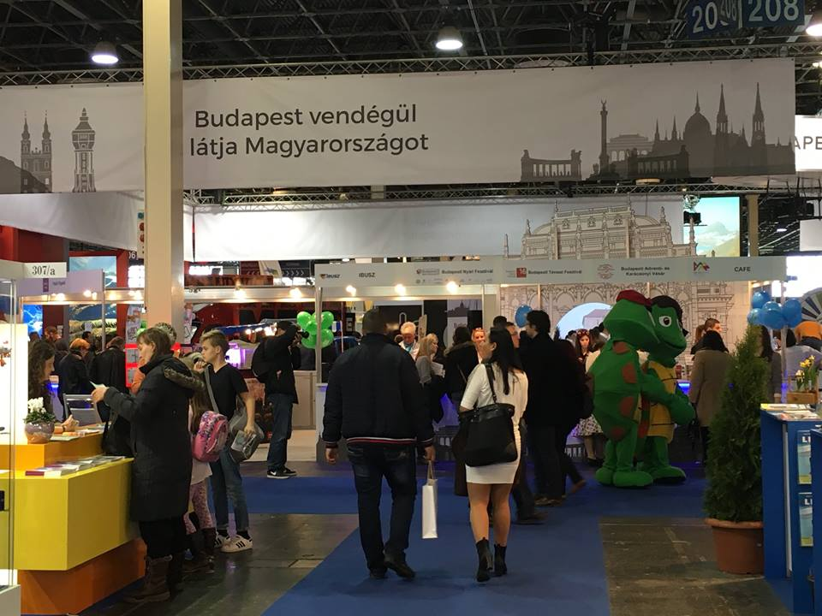
Picture 2: Pavilion Budapest
Source:
KSH: HUNGARIAN CENTRAL STATISTICAL OFFICE. (2016, March 11). STATISTICALTOURISM REPORT Q4, 2015. Retrieved March 11, 2016, from ksu.hu: http://www.ksh.hu/docs/eng/xftp/gyor/nku/enku1512.pdf

