December 2016

Haguer Magdi, Head of FIT Office
Embassy of Belgium
Flanders Investment & Trade Cairo
20 Kamel El Shennawy Street
Garden City 11511 Cairo - Egypt
cairo@fitagency.com

Construction & Real Estate
in Egypt

Industry overview

  - Egypt’s construction and building sector, which accounted for 4.8% of Egypt’s GDP, was on track in FY 2015, building on its strong performance from the previous fiscal year. The sector grew by 9.7% in the past fiscal year, further expanding from a 7.4% growth in FY 2014.

Within the same context of investments in construction and building activity, the value of investments rose by 43.2% in local terms in FY 2015 to reach LE 3.7 billion (US $ 506.2 million), following a contraction of 19.1% in FY 2014, as per the Central Bank. The share of investment in construction out of total investments in the country rose from 1.0% in FY 2014 to 1.1 % in FY 2015.

Egypt’s population reached 92 million in December 2016, and with much of the population residing along the Nile Delta area and in Cairo, it is no surprise the government selected housing and de-urbanization as main priority. Egypt’s Ministry for Housing estimated that 500,000 new homes need to be built every year for the next five years to keep pace with a population expanding at a rate of 2% per year.

The Egyptian authorities supported the construction sector through several initiatives in 2015. The most significant one is the ‘Tahya Misr Fund’, which includes LE 1 billion, for the social housing scheme for youth.

Furthermore, the Egyptian Housing Ministry signed preliminary deals with four real estate developers for four projects. The deals, worth US $ 12.7 billion, were signed with Mountain View, Palm Hills, Sisban Holdings and a consortium of Arab firms. The projects include the development of 500 acres in New Cairo, and the development of 470 acres in 6th of October City. It is worth mentioning that because of the construction boom in Egypt, especially in the real estate sector, there is a huge potential for Belgian contractors and architects.

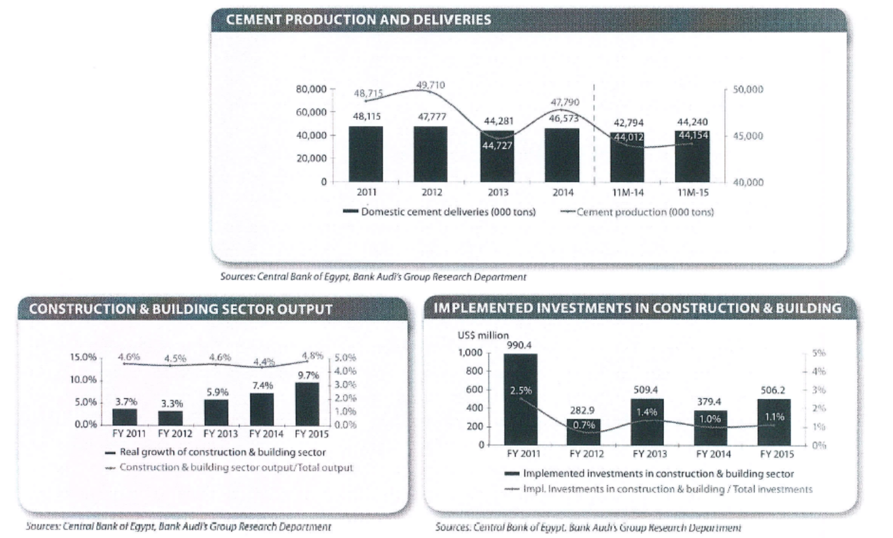

Top construction companies in Egypt

No | Name of the company | Type | Links
1 | Hassan Allam for Construction | Private | http://www.allamsons.com/Construction/
2 | Dar El Handassa | Private | http://www.dargroup.com/
3 | The Arab Contractors (Osman Ahmed Osman) | State Owned Enterprise | http://www.arabcont.com/english/default.aspx
4 | SIAC (Industrial Construction and Engineering Company) | Private | http://www.siac.com.eg/
5 | DETAC | Private | http://detac.com.eg/
6 | Al Marasem International for Development Company | Private | https://www.linkedin.com/company/al-marasem-international-for-development-company
7 | Talaat Mostafa Group (TMGH) | Private | http://new.talaatmoustafa.com/
8 | Me’maar Al Morshedy | Private | http://morshedy.com/
9 | Orascom Construction Industries (OCI) | Private | http://www.orascom.com/

Top worldwide construction companies operating in Egypt

No | Name of the company | Link
1 | Hill International | https://www.hillintl.com/
2 | Emaar Misr for Development | http://www.emaarmisr.com/
3 | DAMAC | https://www.damacproperties.com/en/media-centre/press-releases/damac-properties-awards-more-aed-12-billion-construction-contracts-2015
4 | CRC - Dorra Group | http://www.dorra.com/crc/
5 | Kingdom Holding Company | http://www.kingdom.com.sa/

Real Estate Sector

With a growing population and an already well-established market, the opportunities for investing in Egyptian real estate are prominent. There is a great demand for residential construction in Egypt where there is a high population growth rate and a high urbanization rate. Such demand is mainly driven by the desire for low and middle income housing; a gap that is yet to be satisfied. It is also important to note that 29% of the population is under 40 years old and almost half of the Egyptian population is under 19 years old, as this suggests a continuation in the demand for various forms of real estate within the country. This sector already contributes significantly to the Egyptian economy by impacting around 90 industries relating to construction and 8% of the overall labour force.

Strong Policy Support for Real Estate Investment

- Dozens of planned mega-projects and public works initiatives mean that the contracting industry is facing a sizeable project pipeline across all segments of the market.
- New policy is being implemented that aims to tighten regulations on land purchases. Classifying developers by track record and capacity for development, and awarding land plots to companies that are able to develop them most effectively.
- In the first quarter of 2015 the Egyptian government announced plans to offer state land to private developers on a revenue-sharing-basis. This new model will allow the government to generate revenue from public lands in a transparent manner, while easing the difficulties with land acquisition and the constraints on supply for private developers. As well as helping to moderate land price inflation, also this new system will allow the government to offer land to private developers in exchange for a certain quota of affordable units in any subsequent development.
- The government plans to increase the number of new cities from 27 to 59 by the end of 2017, which entails a growing market demand and potential for large investments in this sector.
- The government has heavily promoted mortgages since 2005. As for real estate developers, the Egyptian Ministry of Housing has decided to revalue 110,200 m² of empty land that are part of the 966,000 m² allocated to Palm Hills Developments for a project in New Cairo.

Source: General Authority for Investment & Free Zones

Top Real Estate Developers in Egypt

No | Name of the company | Link
1 | Palm Hills | http://www.palmhillsdevelopments.com/
2 | SODIC | http://sodic.com/
3 | Amer Group | http://www.amer-group.com/Home
4 | Hassan Allam Properties | http://www.allamsons.com/Properties/
5 | Saudi Egyptian Construction Company (SECON) | http://www.secon-realestate.com/?lang=en
6 | Egyptian Resort Company (ERC) | http://www.erc-egypt.com/
7 | Redcon Construction Company | http://www.redconcon.com/
8 | Tatweer Misr | http://www.tatweermisr.com/tatweer_frontend/
9 | Diar Real Estate Investment Company | http://www.qataridiar.com/English/Pages/default.aspx

Trade exhibitions for construction

No | Name of the exhibition | Link
1 | Projex Africa (The Future Building and Construction Trade Fair) | http://www.projexafrica.net/
2 | The specialized Exhibition for Ceramic and Sanitary work | http://www.ics-inegypt.com/site/
3 | City Scape Egypt | http://www.cityscapeegypt.com/
4 | Build Expo | http://www.buildexpoegypt.com/
5 | Egy Hospital Build (Egy Medica) | https://www.egymedica.com/
6 | Glass World | http://glassworldex.com/
7 | Windorex Egypt | http://www.windoorex.com/
8 | Egypt Building Show | http://www.egyptbuildingshow.com/egybsh/
9 | The Big 5 Construct Egypt | http://www.thebig5constructegypt.com/

Governmental organizations/associations

No | Name of the organization | Link
1 | Ministry of Housing, Utilities and Urban Development | http://moh.gov.eg/en/en_design/Default_en.aspx
2 | The Arab Federation For Engineering Industries | http://www.arabengineeringindustries.org/
3 | General Authority for Investment | http://www.gafi.gov.eg/English/Pages/default.aspx
4 | Egyptian Federation for Construction and Building Contractors | http://www.tasheed.org/ar/Default.aspx
5 | New Urban Community Authority | http://www.newcities.gov.eg/english/default.aspx
6 | Housing & Building National Research Center | http://www.hbrc.edu.eg/en/Home.html
7 | Egyptian Green Building Council | http://egypt-gbc.org/index.html
8 | The Engineering Export Council of Egypt | http://www.eec-eg.org/WebPages/Common/Home.aspx

Disclaimer
The information in this publication is provided for background information that should enable you to get a picture of the subject treated in this document. It is collected with the greatest care on the bases of all data and documentation available at the moment of publication. Thus this publication was never intended to be the perfect and correct answer to your specific situation. Consequently it can never be considered a legal, financial or other specialized advice. Flanders Investment & Trade (FIT) accepts no liability for any errors, omissions or incompleteness, and no warranty is given or responsibility accepted as to the standing of any individual, firm, company or other organization mentioned.

