USA METROPOLITAN REGIONS BY GDP

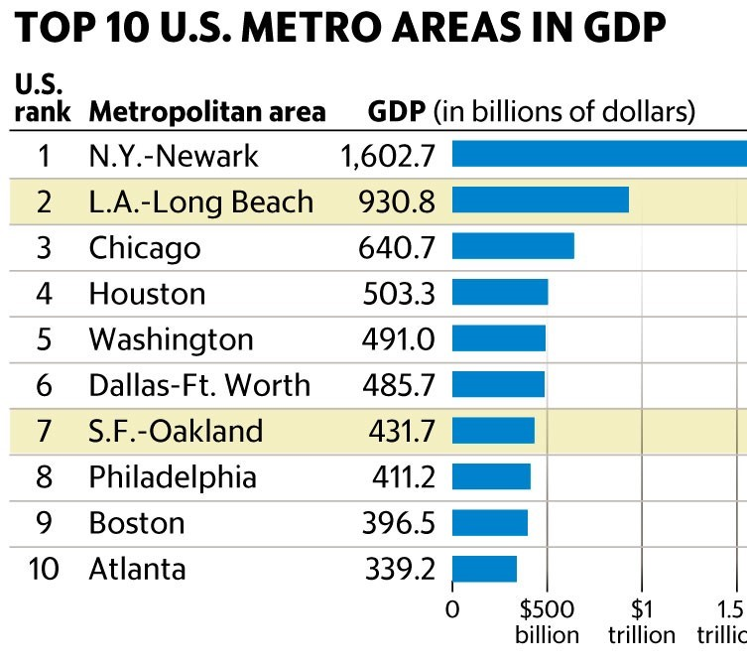
Source: Bureau of Economic Analysis

