BELGIAN INVESTMENTS IN CALIFORNIA – JOBS BY REGION

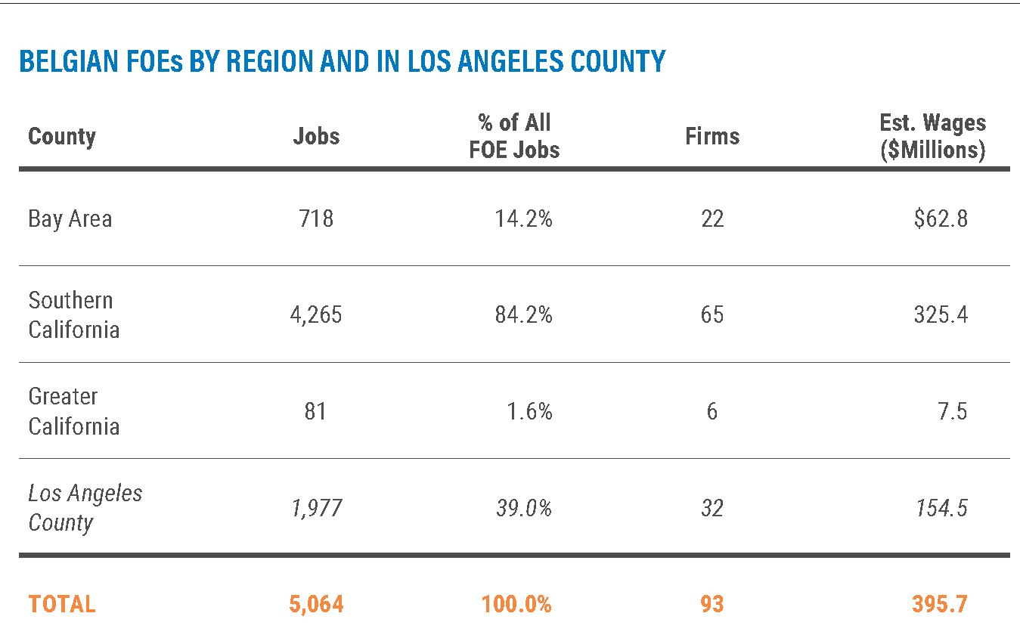
Source: Foreign Direct Investment in California 2020 - WTCLA

